WELCOME.
Parish of Cororooke.
P O Box 27, Cororooke 3254.
Phone: 5233 1282.
Email: cororooke@ballarat.catholic.org.au
Moderator: Liz McGuane 52331222 0427041072
Visiting Priest:
School Principal: Anne Ruddell. 52331464.
St Brendan’s: 9.00am Sunday.
St Joseph’s: 10.30am Sunday.

ST.BRENDAN’S: Sunday 23rd July 9.00am
Communion Minister: M.O’Shea
Commentator: E.McGuane
Reader: Lachie Speirs
Organist: Liz McGuane
Procession of gifts. Jodie Budge
Lay Leader

ST.JOSEPHS’ Sunday 23rd July 10:30 a.m.
Communion Minister: D.Ryan
Family: McGuane Family
Lay Leaders:

ALTAR & SACRISTY DUTIES:
St. Joseph’s:
July: McCormick
August: B & K McGuane

St. Brendans’:
16th/23rd July: C Ryan/ K O’Donnell
30th July/ 6th Aug. J.O’Dowd/ H.Holland

COUNTERS;
16th July: P. O’Shea
3oth July A.McCarthy

DATES TO REMEMBER…

- Thomas Carr Mass, August 6th, 2017. @11.00am.
- Parish Directory are at the back of both Churches for all parishioners.
- St Brendan’s liturgy rosters are at the back of St Brendan’s church with names on them. Please collect.
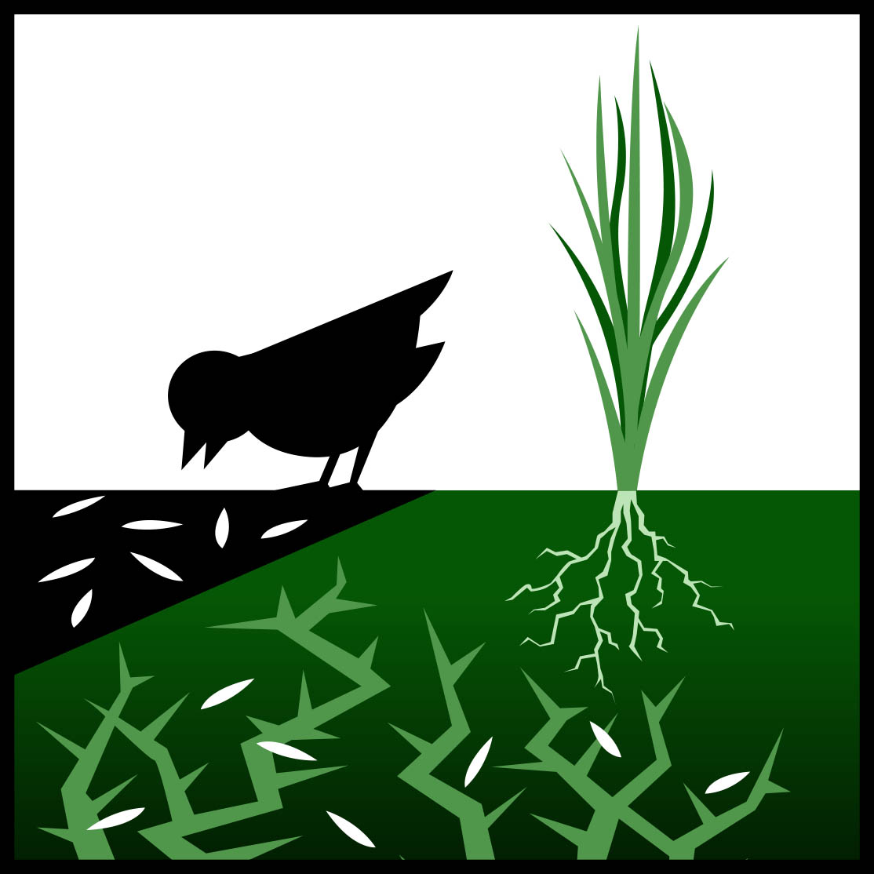

RECENT DEATHS: Dot McGee.

ANNIVERSARIES:
Daniel, Mary & Margaret McGuane,
Tom Delaney, Win O’Brien, Mick Eastaughffe,

SICK: Fr. Brian Russell, Loretta Kervin,
Nathan DeLorenzo, Peter Stewart, Helen Hunt,
Courtney McLennan, Amber Bayne,
Mitchell Johnstone, Maddi Allardyce
Steve Molloy (Hickman’s cousin].

Annual Collection for the Pope
A reminder that the Annual Collection for the Holy Father is to be taken up on the weekends of July 1 & 2 or July 8 & 9, 2017.
I commend the 2017 Appeal to you and your parishioners. Yours in Christ
Paul Bird CSSR , Bishop of Ballarat.

The Catholic Women’s League Colac Branch is having a fundraising screening of the movie “The Case for Christ”, on Sunday July 30th at 2 pm at Colac Cinemas. Tickets are $15 and can be purchased at Colac Cinema’s Ticket Office

Visitor’s Lost Watch: Men’s Gold Face Watch with worn strap. If you found it contact: Marita 52331304.

REFLECTION by Fr Michael Tate
Here is Jesus telling another story about nature, in this case about soil good enough to bear a crop. Is he just a keen observer of the farmers of his time? No.
Throughout the Gospel there is a harmony between Jesus and the natural creation of a profound kind.
But St Paul intuited that link at a profound level in the case of the Risen Lord. This led him to make the most amazing claim that: ‘The creation itself would be set free from its slavery to decay in order to share the freedom associated with the glory of the children of God.’
We, and the whole cosmos, share the legacy of a common destiny brought about by the powerful victory of Christ over the final instance of decay, destruction and every type of death.
We could pause a moment to pray with the angels as we do at every Mass:
‘Holy, Holy, Holy Lord God of hosts. Heaven and earth are full of your glory. Hosanna in the highest.”

Sunday 16th July, 2017
15th Sunday in Ordinary Time. Year A
First Reading Is 55:10-11 A reading from the prophet Isaiah The rain makes the earth fruitful. Thus says the Lord: ‘As the rain and the snow come down from the heavens and do not return without watering the earth, making it yield and giving growth to provide seed for the sower and bread for the eating, so the word that goes from my mouth does not return to me empty, without carrying out my will and succeeding in what it was sent to do.’

Responsorial Psalm Ps 64:10-14. R. Lk 8:8 (R.) The seed that falls on good ground will yield a fruitful harvest.
1. You care for the earth, give it water, you fill it with riches. Your river in heaven brims over to provide its grain. (R.)
2. And thus you provide for the earth; you drench its furrows, you level it, soften it with showers, you bless its growth. (R.)
3. You crown the year with your goodness. Abundance flows in your steps, in the pastures of the wilderness it flows. (R.)
4. The hills are girded with joy, the meadows covered with flocks, the valleys are decked with wheat. They shout for joy, yes, they sing. (R.)

Second Reading Rom 8:18-23 A reading from the letter of St Paul to the Romans All creation is waiting for the revelation of the children of God. I think that what we suffer in this life can never be compared to the glory, as yet unrevealed, which is waiting for us. The whole creation is eagerly waiting for God to reveal his sons. It was not for any fault on the part of creation that it was made unable to attain its purpose, it was made so by God; but creation still retains the hope of being freed, like us, from its slavery to decadence, to enjoy the same freedom and glory as the children of God. From the beginning till now the entire creation, as we know, has been groaning in one great act of giving birth; and not only creation, but all of us who possess the first-fruits of the Spirit, we too groan inwardly as we wait for our bodies to be set free.

Gospel Acclamation Alleluia, alleluia! The seed is the word of God, Christ is the sower; all who come to him will live for ever. Alleluia!

Gospel Mt 13:1-23 A reading from the holy Gospel according to Matthew A sower went out to sow. Jesus left the house and sat by the lakeside, but such crowds gathered round him that he got into a boat and sat there. The people all stood on the beach, and he told them many things in parables. He said, ‘Imagine a sower going out to sow. As he sowed, some seeds fell on the edge of the path, and the birds came and ate them up. Others fell on patches of rock where they found little soil and sprang up straight away, because there was no depth of earth; but as soon as the sun came up they were scorched and, not having any roots, they withered away. Others fell among thorns, and the thorns grew up and choked them. Others fell on rich soil and produced their crop, some a hundredfold, some sixty, some thirty. Listen, anyone who has ears!’ Then the disciples went up to him and asked, ‘Why do you talk to them in parables?’ ‘Because’ he replied ‘the mysteries of the kingdom of heaven are revealed to you, but they are not revealed to them. For anyone who has will be given more, and he will have more than enough; but from anyone who has not, even what he has will be taken away. The reason I talk to them in parables is that they look without seeing and listen without hearing or understanding. So in their case this prophecy of Isaiah is being fulfilled: You will listen and listen again, but not understand, see and see again, but not perceive. For the heart of this nation has grown coarse, their ears are dull of hearing, and they have shut their eyes, for fear they should see with their eyes, hear with their ears, understand with their heart, and be converted and be healed by me. ‘But happy are your eyes because they see your ears because they hear! I tell you solemnly, many prophets and holy men longed to see what you see, and never saw it; to hear what you hear, and never heard it. ‘You, therefore, are to hear the parable of the sower. When anyone hears the word of the kingdom without understanding, the evil one comes and carries off what was sown in his heart: this is the man who received the seed on the edge of the path. The one who received it on patches of rock is the man who hears the word and welcomes it at once with joy. But he has no root in him, he does not last; let some trial come, or some persecution on account of the word, and he falls away at once. The one who received the seed in thorns is the man who hears the word, but the worries of this world and the lure of riches choke the word and so he produces nothing. And the one who received the seed in rich soil is the man who hears the word and understands it; he is the one who yields a harvest and produces now a hundredfold, now sixty, now thirty.

