WELCOME.
Parish of Cororooke.
P O Box 27, Cororooke 3254.
Phone: 5233 1282.
Email: cororooke@ballarat.catholic.org.au
Moderator: Liz McGuane 52331222 0427041072
Visiting Priest: -
School Principal: Anne Ruddell. 52331464.
St Brendan’s: 9.00am Sunday.
St Joseph’s: 10.30am Sunday.

ST. BRENDAN’S: Sunday.22/10/17 @ 9.00am.
Commentator: First Communion: TBC
Reader:
Communion:
Organist:
Procession of gifts
Lay Leader:

ST.JOSEPH’S Sunday 22/10/17 @10.30am.
Family: G&M Carmody
Communion Minister: A Convery
Lay Leaders:

ALTAR & SACRISTY DUTIES:
St. Joseph’s:
Oct. Mulheron/Sherman
November: Grist

St. Brendan’s
15th/22nd Oct. K. Speirs/D. McCarthy

COUNTERS

RECENT DEATHS:
ANNIVERSARIES: Nell Sherman. Jeremy Fleming, Bobby Boylan, Pat O’Brian, Gavin Kavenagh, Margaret Quigley.

SICK: Fr. Brian Russell, Loretta Kervin
Nathan De Lorenzo, Peter Stewart, Helen Hunt, Courtney McLennan, Mitchell Johnstone, Maddi Allardyce.

DATES TO REMEMBER:
October 22nd: 1st Communion Mass @ 9.30am.
October 31st: St. Brendan’ School Mission Day.
10.00 am Liturgy. All welcome.
Nov 23rd: L/ship/Finance Mtg 7:30 @School Hall
Please keep the sacramental children and their families in your prayers. Joe Chant, Jodie Budge, Andrew Demasi , Lucas Ruddell, Charlie Robb, Tristan D’Altera, Mitchell Rolland,
Johnny Donovan. First Communion Mass will be @ 9.30am on October 22nd, 2017.

Volunteers Needed: Cleaning and packing of the Parish House will be after Mass on Sunday 29th October. Please come prepared. The Parish house is to be leased to Thomas Carr College and so we will need to sort/move things. We would appreciate if you have any shoeboxes or packing boxes to donate.

TRINITY COLLEGE CELEBRATE 50 YEARS October. 27th, 28th and 29th, 2017.
* Friday 27th Oct. Blessing and Official Opening of the “Jubilee Art Centre” and the all - weather oval plus numerous student activities.
* Sat 28th Oct. Gala Concert in “Jubilee Centre”.
* Sunday 29th Oct – Mass 11am at St Mary’s Church with Ministries to be under taken by present and former students. 12noon - 3pm “Hospitality at the College” - with opportunities for Tour of College. (Further details later.) Enquiries: Events Coordinator: Sally Forrester: 5233 9200.

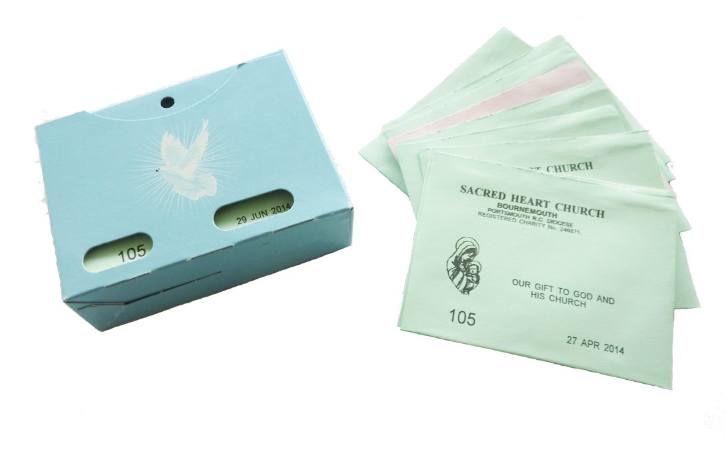
PLANNED GIVING ENVELOPES IN THE BACK OF BOTH CHURCHES. PLEASE TAKE YOURS.

Step Up For Ruben.
Francesca Hickman and her partner Aidan Long ( 2nd cousin to Pat O’Shea!) ,are currently volunteering in Kenya at the Ruben Centre. The centre provides education for 2700 children from the Mukura slums. It also provides the mothers with cottage industry skills to enable them to have a source of income. The Centre is raising funds to provide a birthing suite, as the women have no access to a hospital.
Francesca and Aidan along with Chris Hickman and 4 extended family members from New Zealand, are climbing Kilimanjaro in Dec, they have a fundraising website for anyone who may wish donate, all funds going towards the birthing suite.
https://www.gofundme.com/step-up-for-ruben


28th Sunday in Ordinary.
Time Year A.
15th October, 2017.

First Reading Is 25:6-10 A reading from the prophet Isaiah The Lord will prepare a feast and will wipe away the tears from every cheek. On this mountain, the Lord of hosts will prepare for all people a banquet of rich food, a banquet of fine wines, of food rich and juicy, of fine strained wines. On this mountain he will remove the mourning veil covering all peoples, and the shroud enwrapping all nations, he will destroy Death for ever. The Lord will wipe away the tears from every cheek; he will take away his people’s shame everywhere on earth, for the Lord has said so. That day, it will be said: See, this is our God in whom we hoped for salvation; the Lord is the one in whom we hoped. We exult and we rejoice that he has saved us; for the hand of the Lord rests on this mountain.
Responsorial Psalm Ps 22. R. v.6 (R.) I shall live in the house of the Lord all the days of my life.
1. The Lord is my shepherd; there is nothing I shall want. Fresh and green are the pastures where he gives me repose. Near restful waters he leads me, to revive my drooping spirit. (R.)
2. He guides me along the right path; he is true to his name. If I should walk in the valley of darkness no evil would I fear. You are there with your crook and your staff; with these you give me comfort. (R.)
3. You have prepared a banquet for me in the sight of my foes. My head you have anointed with oil; my cup is overflowing. (R.))
4. Surely goodness and kindness shall follow me all the days of my life. In the Lord’s own house shall I dwell for ever and ever. (R.)

Second Reading Phil 4:12-14. 19-20 A reading from the letter of St Paul to the Philippians I am able to do all things in him who strengthens me. I know how to be poor and I know how to be rich too. I have been through my initiation and now I am ready for anything anywhere: full stomach or empty stomach, poverty or plenty. There is nothing I cannot master with the help of the One who gives me strength. All the same, it was good of you to share with me in my hardships. In return my God will fulfil all your needs, in Christ Jesus, as lavishly as only God can. Glory to God, our Father, for ever and ever. Amen.

Gospel Acclamation See Eph 1:17-18 Alleluia, alleluia! May the Father of our Lord Jesus Christ enlighten the eyes of our heart that we might see how great is the hope to which we are called. Alleluia!

Gospel Mt 22:1-14 A reading from the holy Gospel according to Matthew Whomsoever you find invite to the wedding. Jesus said to the chief priests and elders of the people: ‘The kingdom of heaven may be compared to a king who gave a feast for his son’s wedding. He sent his servants to call those, who had been invited, but they would not come. Next, he sent some more servants. “Tell those who have been invited” he said “that I have my banquet prepared, my oxen and fattened cattle have been slaughtered, everything is ready. Come to the wedding.” But, they were not interested: one went off to his farm, another to his business, and the rest seized his servants, maltreated them and killed them. The king was furious. He dispatched his troops, destroyed those murderers and burnt their town. Then he said to his servants, “The wedding is ready; but as those who were invited proved to be unworthy, go to the crossroads in the town and invite everyone you can find to the wedding.” So these servants went out onto the roads and collected together everyone they could find, bad and good alike; and the wedding hall was filled with guests. When the king came in to look t the guests he noticed one man who was not wearing a wedding garment, and said to him, “How did you get in here, my friend, without a wedding garment?” And the man was silent. Then the king said to the attendants, “Bind him hand and foot and throw him out into the dark, where there will be weeping and grinding of teeth.” For many are called, but few are chosen.’

Year of the Youth 2018
This will be starting Advent Dec 3rd 2017, with the theme “Open New Horizons For Spreading Joy”.
How might we celebrate this within our Parish?
youth@ballarat.catholic.org.au Email them with your ideas.

