WELCOME.
Parish of Cororooke.
P O Box 27, Cororooke 3254.
Phone: 5233 1282.
Email: cororooke@ballarat.catholic.org.au
Moderator: Liz McGuane 52331222 0427041072
Visiting Priest: -
School Principal: Anne Ruddell. 52331464.
St Brendan’s: 9.00am Sunday.
St Joseph’s: 10.30am Sunday.

ST. BRENDAN’S: Sunday.8/10/17 @ 9.00am.
Commentator: M Finn
Reader: A McCarthy and St Joseph’s 10:30 am.
Organist: 5th Sunday Mass at St Brendan’s 9am /St Joseph’s Lay Led
Procession of gifts. T D’Altera
Lay Leader: L. McGuane/A. Ruddell.

ST.JOSEPH’S Sunday8/10/17 @10.30am.
Family: Melvile
Communion Minister: J Sherman.
Lay Leaders: A Convery/L Darcy

ALTAR & SACRISTY DUTIES:
St. Joseph’s:
Oct. Mulheron/Sherman
November: Grist

St. Brendan’s
1st/8th October. C.Ryan/K. O’Donnell
15th/22nd Oct. K. Speirs/D. McCarthy
COUNTERS

8th Oct: J. Miller.
22nd Oct: P. O’Shea.

RECENT DEATHS: Steve Molloy

ANNIVERSARIES:
Bill Maslin, Herbie Golden ,Barbara Richens, Dean Finlay Kevin Gleeson, Mike Ebling.

SICK: Fr. Brian Russell, Loretta Kervin,
Nathan De Lorenzo, Peter Stewart, Helen Hunt, Courtney McLennan, Mitchell Johnstone, Maddi Allardyce.

DATES TO REMEMBER:
October 12th: Finance Meeting 7.00pm
Leadership Team Meeting 7.30pm
October 22nd: 1st Communion Mass @ 9.30am.
October 31st: St. Brendan’ School Mission Day.
10.00 am Liturgy. All welcome.

Please keep the sacramental children and their families in your prayers. Joe Chant, Jodie Budge, Andrew Demasi , Lucas Ruddell, Charlie Robb, Tristan D’Altera, Mitchell Rolland,
Johnny Donovan. First Communion Mass will be @ 9.30am on October 22nd, 2017.

Volunteers Needed: The Parish house is to be leased to Thomas Carr College and so we will need to sort/move things. If you can lend a hand, please contact one of the Leadership Team – “many hands make light work”. There are two double beds and one single bed if anyone would like to make an offer.

TRINITY COLLEGE CELEBRATE 50 YEARS October. 27th, 28th and 29th, 2017.
* Friday 27th Oct. Blessing and Official Opening of the “Jubilee Art Centre” and the all - weather oval plus numerous student activities.
* Sat 28th Oct. Gala Concert in “Jubilee Centre”.
* Sunday 29th Oct – Mass 11am at St Mary’s Church with Ministries to be under taken by present and former students. 12noon - 3pm “Hospitality at the College” - with opportunities for Tour of College. (Further details later.) Enquiries: Events Coordinator: Sally Forrester: 5233 9200.

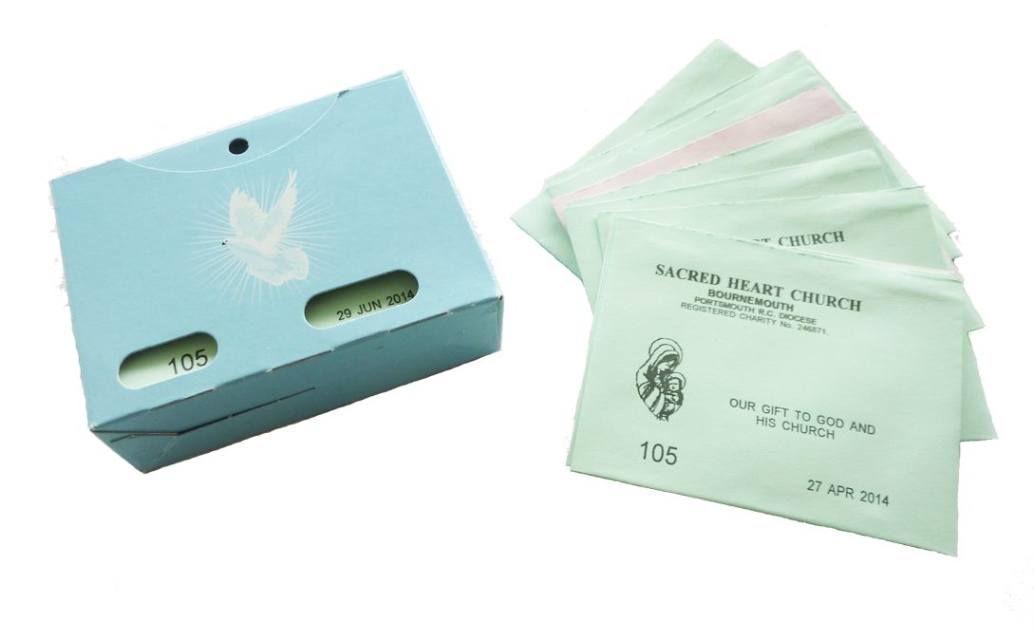
PLANNED GIVING ENVELOPES IN THE BACK OF BOTH CHURCHES. PLEASE TAKE YOURS.

Lunch Invitation: Parishioners/friends are invited to join Cam and Nola for lunch, Wed Oct 4th, noon at Oddfellows. All welcome. Contact Pat and Marita with numbers please. 0409328941


26th Sunday in Ordinary.
Time Year A.
1st October, , 2017.

First Reading Ez 18:25-28 A reading from the prophet Ezekiel. The sinner who decides to turn against sinfulness deserves to live. The word of the Lord was addressed to me as follows: ‘You object, “What the Lord does is unjust.” Listen, you House of Israel: is what I do unjust? Is it not what you do that is unjust? When the upright man renounces his integrity to commit sin and dies because of this, he dies because of the evil that he himself has committed. When the sinner renounces sin to become law-abiding and honest, he deserves to live. He has chosen to renounce all his previous sins; he shall certainly live; he shall not die.’
Responsorial Psalm Ps 24:4-9. R. v.6 (R.) Remember your mercies, O Lord.
1. Lord, make me know your ways. Lord, teach me your paths. Make me walk in your truth, and teach me: for you are God my saviour. (R.)
2. Remember your mercy, Lord, and the love you have shown from of old. Do not remember the sins of my youth. In your love remember me, because of your goodness, O Lord. (R.)
3. The Lord is good and upright. He shows the path to those who stray, he guides the humble in the right path; he teaches his way to the poor. (R.)

Second Reading Phil 2:1-11 A reading from the letter of St Paul to the Philippians In your minds you must be the same as Christ Jesus. If our life in Christ means anything to you, if love can persuade at all, or the Spirit that we have in common, or any tenderness and sympathy, then be united in your convictions and united in your love, with a common purpose and a common mind. That is the one thing, which would make me completely happy. There must be no competition among you, no conceit; but everybody is to be self-effacing. Always consider the other person to be better than yourself, so that nobody thinks of his own interests first but everybody thinks of other people’s interests instead. In your minds you must be the same as Christ Jesus: His state was divine, yet he did not cling to his equality with God but emptied himself to assume the condition of a slave, and became as men are; and being as all men are, he was humbler yet, even to accepting death, death on a cross. But God raised him high and gave him the name which is above all other names so that all beings in the heavens, on earth and in the underworld, should bend the knee at the name of Jesus and that every tongue should acclaim Jesus Christ as Lord, to the glory of God the Father.

Gospel Acclamation Jn 10:27 Alleluia, alleluia! My sheep listen to my voice, says the Lord; I know them, and they follow me. Alleluia!

Gospel Mt 21:28-32 A reading from the holy Gospel according to Matthew He went out moved by regret. The tax collectors and prostitutes will precede you into the kingdom of God. Jesus said to the chief priests and the elders of the people, ‘What is your opinion? A man had two sons. He went and said to the first, “My boy, you go and work in the vineyard today.” He answered, “I will not go,” but afterwards thought better of it and went. The man then went and said the same thing to the second who answered, “Certainly, sir,” but did not go. Which of the two did the father’s will?’ ‘The first’ they said. Jesus said to them, ‘I tell you solemnly, tax collectors and prostitutes are making their way into the kingdom of God before you. For John came to you, a pattern of true righteousness, but you did not believe him, and yet the tax collectors and prostitutes did. Even after seeing that, you refused to think better of it and believe in him.’

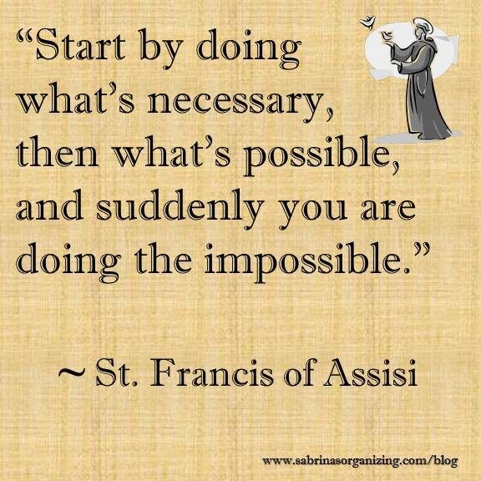

Congratulations to Ruby Manson and Jack Williams on their B&F awards.

Congratulations to Andre Delorenzo and Amanda Devlin on their engagement!

