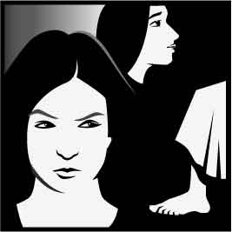
Sunday, 17th July, 2016.
16th Sunday in Ordinary Time!
Year C.

First Reading Gn 18:1-10 A reading from the book of Genesis Lord, do not bypass your servant. The Lord appeared to Abraham at the Oak of Mamre while he was sitting by the entrance of the tent during the hottest part of the day. He looked up, and there he saw three men standing near him. As soon as he saw them he ran from the entrance of the tent to meet them, and bowed to the ground. ‘My lord,’ he said, ‘I beg you, if I find favour with you, kindly do not pass your servant by. A little water shall be brought; you shall wash your feet and lie down under the tree. Let me fetch a little bread and you shall refresh yourselves before going further. That is why you have come in your servant’s direction.’ They replied, ‘Do as you say.’ Abraham hastened to the tent to find Sarah. ‘Hurry,’ he said, ‘knead three bushels of flour and make loaves.’ Then running to the cattle Abraham took a fine and tender calf and gave it to the servant, who hurried to prepare it. Then taking cream, milk and the calf he had prepared, he laid all before them, and they ate while he remained standing near them under the tree. ‘Where is your wife Sarah?’ they asked him. ‘She is in the tent,’ he replied. Then his guest said, ‘I shall visit you again next year without fail and your wife will then have a son.’ The word of the Lord.
Responsorial Psalm Ps 14:2-5. R. v.1
(R.) The just will live in the presence of the Lord.
1. Lord, who shall dwell on your holy mountain? He who walks without fault; he who acts with justice and speaks the truth from his heart; he who does not slander with his tongue. (R.)
2. He who does no wrong to his brother, who casts no slur on his neighbour, who holds the godless in disdain, but honours those who fear the Lord. (R.)
3. He who keeps his pledge, come what may; who takes no interest on a loan and accepts no bribes against the innocent. Such a man will stand firm for ever. (R.)
Second Reading Col 1:24-28 A reading from the letter of St Paul to the Colossians The mystery hidden for centuries has now been revealed to his saints. It makes me happy to suffer for you, as I am suffering now, and in my body to do what I can
to make up all that has still to be undergone by Christ for the sake of his body, the Church. I became the servant of the Church when God made me responsible for delivering God’s message to you, the message which was a mystery hidden for generations and centuries and has now been revealed to his saints. It was God’s purpose to reveal it to them and to show all the rich glory of this mystery to pagans. The mystery is Christ among you, your hope of glory: this is the Christ we proclaim, this is the wisdom in which we thoroughly train everyone and instruct everyone, to make them all perfect in Christ. The word of the Lord.
Gospel Acclamation See Lk 8:15 Alleluia, alleluia! Happy are they who have kept the word with a generous heart and yield a harvest through perseverance. Alleluia!
Gospel Lk 10:38-42 A reading from the holy

Gospel according to Luke Martha took up the

duties in the house. Mary chose the better part. Jesus came to a village, and a woman named Martha welcomed him into her house. She had a sister called Mary, who sat down at the Lord’s feet and listened to him speaking. Now Martha who was distracted with all the serving said, ‘Lord, do you not care that my sister is leaving me to do the serving all by myself? Please tell her to help me.’ But the Lord answered: ‘Martha, Martha,’ he said, ‘you worry and fret about so many things, and yet few are needed, indeed only one. It is Mary who has chosen the better part; it is not to be taken from her.’ The Gospel of the Lord

RECENT DEATHS: Frank Lenehan(Ann Buchanan’s father),
Lyn Illet (Jack & Pats daughter in law)

ANNIVERSARIES:
Tom Delaney,Win O’Brien, Mick Eastaughffe,

SICK: Lorraine Russell, Loretta Kervin, Nathan DeLorenzo, Peter Stewart, Helen Hunt, Margaret Sinclair, Courtney McLennan, Michelle Smith,
Ange English (Hickmans neice)

Altar Servers and Projectionists.
Children are welcome to participate they will be supported by an adult if required. See Lucy Darcy.

WELCOME.
Parish of Cororooke.
P O Box 27, Cororooke 3254.
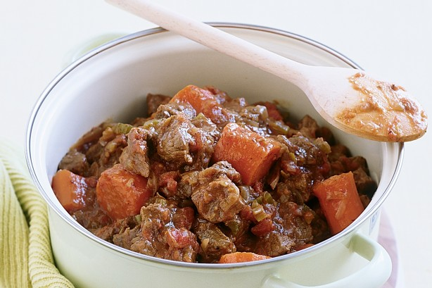
Phone: 5233 1282.

Moderator: Lucy Darcy 52331228.
Visiting Priest: Fr Dan Arundell
(Sacramental responsibility for our communities including Baptisms, Wedding & Funerals). 53387804.
School Principal: Anne Ruddell. 52331464.
St Brendan’s: 9.00am Sundays.
St Joseph’s: 10.30am Sundays.

ST BRENDAN’S: (9.00am 24th July, 2016)
Communion Minister: M Carmody
Commentator: M McGuane
Reader: A McCarthy
Organist: L McGuane
Procession Gifts: X Spiers
Lay Leaders:

ST. JOSEPH’S: 10.30am NO MASS 24/07
Communion Minister
Family:
Lay Leaders

ALTAR & SACRISTY DUTIES:
St Joseph’s:
July: McCormick.
August: B. & K. McGuane

St Brendan’s:
24th/31st July J Dimasi/D Sutherland
7th /14th August T Hickey/C Finlay

COUNTERS:
Next week: L Darcy 24/07
Counters please note. Starting July money only needs counting every 2nd weekend!

Liturgy Preparation Roster:
July: Caroline Grist/Jill O’Dowd.
Aug: Liz. Anne, Marg.

Dates to Remember.
10th August: Finance Meeting. 8.00pm.
11th August: Leadership Meeting. 7.30pm.


Cuttings wanted for school garden! Please leave at the School.

KEEP THIS DATE FREE.
CELEBRATION AND FAREWELL
On Sunday, 24th July, Fr Dan celebrates his Diamond Jubilee of Ordination, and his last Mass at Cororooke. A shared luncheon will be held after Mass in the School Hall. Please co-ordinate with Anne McCarthy or Carmel Finlay numbers attending and if you are able to provide a casserole. Also, please note Mass will not be conducted at St Joseph’s on this important day! Ph 52331480 Carmel
This will be our last opportunity to thank Fr. Dan for his ministry to us. All Welcome!!

Reflection by Michael Tate Jesus turned the customs and taboos of his society upside down. In this Gospel, against all the rules of segregation, Jesus is alone with women who are not his relatives, completely at ease with their hospitality. It is personal relationships, not gender determined relationships, which are important to him. Further, here is Mary assuming the posture of a student at the feet of a Rabbi (teacher) listening to his teaching. We remember that Jesus had chosen his male disciples in order to teach them. Mary chooses Him to teach her! Maybe it was a counter-cultural step too far for Martha. Is that what she is really ‘anxious and troubled’ about? Jesus was willing to upset the social conventions and religious taboos of his day in respect of women. What would be a good contemporary response of the Catholic Church? The word ‘cardinal’ means hinge – ‘hinge of the door’ – an essential part of the structure of the Church which is our home, in which we listen to the words of Jesus Christ. Could the College of Cardinals be supplemented to include women alongside the ordained male prelates? Outstanding women, religious or lay, could head some Vatican departments and take part in the election of the Pope. That would be a strongly symbolic step with repercussions throughout the Church. We could pause for a moment to pray for the Church to show a greater willingness to sit, like Mary, at the feet of Jesus so that we may hear his words: ‘You have chosen the better portion.’

