WELCOME.
Parish of Cororooke.
P O Box 27, Cororooke 3254.
Phone: 5233 1282.
Email: cororooke@ballarat.catholic.org.au
Moderator: Liz McGuane 52331222 0427041072
Visiting Priest: -
School Principal: Anne Ruddell. 52331464.
St Brendan’s: 9.00am Sunday.
St Joseph’s: 10.30am Sunday.

ST. BRENDAN’S: Sunday.15/10/17 @ 9.00am.
Commentator: A. McCarthy
Reader: M. Finn
Communion: M. Shea.
Organist: 5th Sunday Mass at St Brendan’s 9am /St Joseph’s Lay Led
Procession of gifts. T D’Altera
Lay Leader: L. McGuane/A. Ruddell.

ST.JOSEPH’S Sunday 15/10/17 @10.30am.
Family: McGuane
Communion Minister: D. Ryan
Lay Leaders: B & C Hickman

ALTAR & SACRISTY DUTIES:
St. Joseph’s:
Oct. Mulheron/Sherman
November: Grist

St. Brendan’s
1st/8th October. C.Ryan/K. O’Donnell
15th/22nd Oct. K. Speirs/D. McCarthy
COUNTERS

8th Oct: J. Miller.
22nd Oct: P. O’Shea.

RECENT DEATHS:
ANNIVERSARIES:
Kevin Gleeson, Marie Hester, Des Harrington, Rebecca Finn, Mary Anderson, Phillip Sherry,
Alan Matthews.

SICK: Fr. Brian Russell, Loretta Kervin,
Nathan De Lorenzo, Peter Stewart, Helen Hunt, Courtney McLennan, Mitchell Johnstone, Maddi Allardyce.

DATES TO REMEMBER:
October 12th: Finance Meeting 8.00pm
Leadership Team Meeting 7.30pm
October 22nd: 1st Communion Mass @ 9.30am.
October 31st: St. Brendan’ School Mission Day.
10.00 am Liturgy. All welcome.
Please keep the sacramental children and their families in your prayers. Joe Chant, Jodie Budge, Andrew Demasi , Lucas Ruddell, Charlie Robb, Tristan D’Altera, Mitchell Rolland,
Johnny Donovan. First Communion Mass will be @ 9.30am on October 22nd, 2017.

Volunteers Needed: Cleaning and packing of the Parish House will be after Mass on Sunday 29th October. Please come prepared. The Parish house is to be leased to Thomas Carr College and so we will need to sort/move things. We would appreciate if you have any shoeboxes or packing boxes to donate.

TRINITY COLLEGE CELEBRATE 50 YEARS October. 27th, 28th and 29th, 2017.
* Friday 27th Oct. Blessing and Official Opening of the “Jubilee Art Centre” and the all - weather oval plus numerous student activities.
* Sat 28th Oct. Gala Concert in “Jubilee Centre”.
* Sunday 29th Oct – Mass 11am at St Mary’s Church with Ministries to be under taken by present and former students. 12noon - 3pm “Hospitality at the College” - with opportunities for Tour of College. (Further details later.) Enquiries: Events Coordinator: Sally Forrester: 5233 9200.

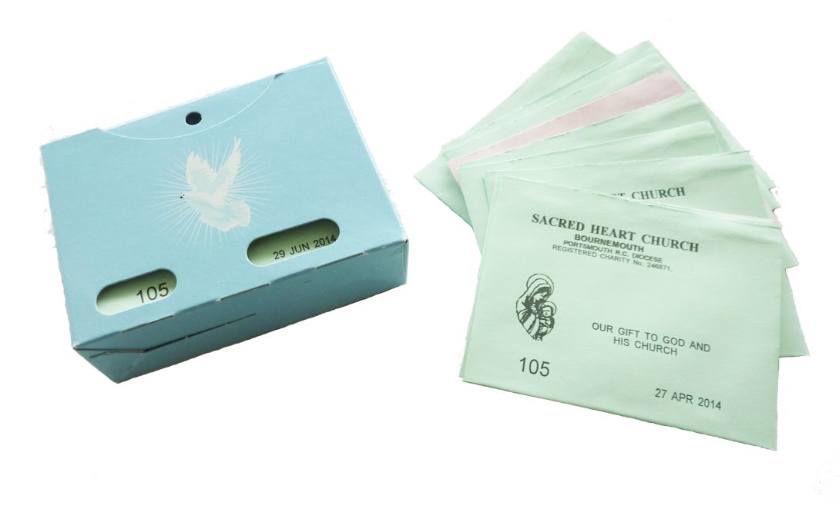
PLANNED GIVING ENVELOPES IN THE BACK OF BOTH CHURCHES. PLEASE TAKE YOURS.


CONGRATULATIONS JOHNNY MILLER.
Johnny has been nominated for the Geelong Advertiser Local Football Personality of the Year. For forty years, Johnny Miller has been keeping time for the Alvie Football Club’s senior team. He did the secretary job for eight years before taking on the presidency, but a year later he returned to the secretary role. And then in 1977 he took on the timekeeping, a job he’s completed week in week out since. “I’ve done a few CDFL grand finals and finals over the years — I usually do two or three every year,” he said.“I’ve been doing that for the last 10 years.
“I just enjoy it. I’m an Aussie man through and through and I’ve got to support the club, so that’s the way I look at it.”

27th Sunday in Ordinary.
Time Year A.
8th October, 2017.

First Reading Is 5:1-7 A reading from the prophet Isaiah The vineyard of the Lord God of hosts is the House of Israel. Let me sing to my friend the song of his love for his vineyard. My friend had a vineyard on a fertile hillside. He dug the soil, cleared it of stones, and planted choice vines in it. In the middle he built a tower, he dug a press there too. He expected it to yield grapes, but sour grapes were all that it gave. And now, inhabitants of Jerusalem and men of Judah, I ask you to judge between my vineyard and me. What could I have done for my vineyard that I have not done? I expected it to yield grapes. Why did it yield sour grapes instead? Very well, I will tell you what I am going to do to my vineyard: I will take away its hedge for it to be grazed on, and knock down its wall for it to be trampled on. I will lay it waste, unpruned, undug; overgrown by the briar and the thorn. I will command the clouds to rain no rain on it. Yes, the vineyard of the Lord of hosts is the House of Israel, and the men of Judah that chosen plant. He expected justice, but found bloodshed, integrity, but only a cry of distress.

Responsorial Psalm Ps 79:9. 12-16. 19-20. R. Is 5:7 (R.) The vineyard of the Lord is the House of Israel.
1. You brought a vine out of Egypt; to plant it you drove out the nations. It stretched out its branches to the sea, to the Great River it stretched out its shoots. (R.)
2. Then why have you broken down its walls? It is plucked by all who pass by. It is ravaged by the boar of the forest, devoured by the beasts of the field. (R.)
3. God of hosts, turn again, we implore, look down from heaven and see. Visit this vine and protect it, the vine your right hand has planted. (R.)
4. And we shall never forsake you again: give us life that we may call upon your name. God of hosts, bring us back; let your face shine on us and we shall be saved. (R.)

Second Reading Phil 4:6-9 A reading from the letter of St Paul to the Philippians Do these things and the God of peace will be with you. There is no need to worry; but if there is anything you need, pray for it, asking God for it with prayer and thanksgiving, and that peace of God, which is so much greater than we can understand, will guard your hearts and your thoughts, in Christ Jesus. Finally, brothers, fill your minds with everything that is true, everything that is noble, everything that is good and pure, everything that we love and honour, and everything that can be thought virtuous or worthy of praise. Keep doing all the things that you learnt from me and have been taught by me and have heard or seen that I do. Then the God of peace will be with you.

Gospel Acclamation See Jn 15:15 Alleluia, alleluia! I call you friends, says the Lord, because I have made known to you everything I have learnt from my Father. Alleluia!

Gospel Mt 21:33-43 A reading from the holy Gospel according to Matthew He leased his vineyard to other farmers. Jesus said to the chief priests and the elders of the people, ‘Listen to another parable. There was a man, a landowner, who planted a vineyard; he fenced it round, dug a winepress in it and built a tower; then he leased it to tenants and went abroad. When vintage time drew near he sent his servants to the tenants to collect his produce. But the tenants seized his servants, thrashed one, killed another and stoned a third. Next he sent some more servants, this time a larger number, and they dealt with them in the same way. Finally he sent his son to them. “They will respect my son,” he said. But when the tenants saw the son, they said to each other, “This is the heir. Come on, let us kill him and take over his inheritance.” So they seized him and threw him out of the vineyard and killed him. Now when the owner of the vineyard comes, what will he do to those tenants?’ They answered, ‘He will bring those wretches to a wretched end and lease the vineyard to other tenants who will deliver the produce to him when the season arrives.’ Jesus said to them, ‘Have you never read in the scriptures: It was the stone rejected by the builders that became the keystone. This was the Lord’s doing and it is wonderful to see? ‘I tell you, then, that the kingdom of God will be taken from you and given to a people who will produce its fruit.’

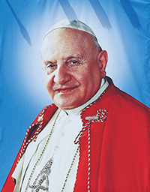
Prayer to St. John XXIII:
St. John XXIII, Your simple and meek persona carried the scent of God & the desire of goodness was inflamed in the heart. Pray for us so that we do not limit ourselves to mourn the darkness but rather to enkindle the light, bringing Christ everywhere and always praying to Mary. Amen.

