
20/05/2018.
Pentecost Sunday.

First Reading Acts 2:1-11 They were all filled with the Holy Spirit, and began to speak different languages. When Pentecost day came round, the apostles had all met in one room, when suddenly they heard what sounded like a powerful wind from heaven, the noise of which filled the entire house in which they were sitting; and something appeared to them that seemed like tongues of fire; these separated and came to rest on the head of each of them. They were all filled with the Holy Spirit, and began to speak foreign languages as the Spirit gave them the gift of speech. Now there were devout men living in Jerusalem from every nation under heaven, and at this sound they all assembled, each one bewildered to hear these men speaking his own language. They were amazed and astonished. ‘Surely’ they said ‘all these men speaking are Galileans? How does it happen that each of us hears them in his own native language? Parthians, Medes and Elamites; people from Mesopotamia, Judaea and Cappadocia, Pontus and Asia, Phrygia and Pamphylia, Egypt and the parts of Libya round Cyrene; as well as visitors from Rome - Jews and proselytes alike - Cretans and Arabs; we hear them preaching in our own language about the marvels of God.’

Responsorial Psalm Ps 103:1. 24. 29-31. 34. R. v.30 (R.) Lord, send out your Spirit and renew the face of the earth. or (R.) Alleluia.
1. Bless the Lord, my soul! Lord God, how great you are, How many are your works, O Lord! The earth is full of your riches. (R.)
2. You take back your spirit, they die, returning to the dust from which they came. You send forth your spirit, they are created; and you renew the face of the earth. (R.)
3. May the glory of the Lord last for ever! May the Lord rejoice in his works! May my thoughts be pleasing to him. I find my joy in the Lord. (R.)

Second Reading 1 Cor 12:3-7, 12-13 In the one Spirit we were all baptised, making one body. No one can say, ‘Jesus is Lord’ unless he is under the influence of the Holy Spirit. There is a variety of gifts but always the same Spirit; there are all sorts of service to be done, but always to the same Lord; working in all sorts of of different ways in different people, it is the same God who is working in all of them. The particular way in which the Spirit is given to each person is for a good purpose. Just as a human body, though it is made up of many parts, is a single unit because all these parts, though many, make one body, so it is with Christ. In the one Spirit we were all baptised, Jews as well as Greeks, slaves as well as citizens, and one Spirit was given to us all to drink.
Gospel Acclamation Alleluia, alleluia! Come, Holy Spirit, fill the hearts of your faithful and kindle in them the fire of your love. Alleluia!

Gospel Jn 20:19-23 As the Father sent me, so I send you: Receive the Holy Spirit. In the evening of the first day of the week, the doors were closed in the room where the disciples were, for fear of the Jews. Jesus came and stood among them. He said to them, ‘Peace be with you,’ and showed them his hands and his side. The disciples were filled with joy when they saw the Lord, and he said to them again, ‘Peace be with you. ‘As the Father sent me, so am I sending you.’ After saying this he breathed on them and said: ‘Receive the Holy Spirit. For those whose sins you forgive, they are forgiven; for those whose sins you retain, they are retained.’

CENTENARY OF THE PARISH OF COROROOKE. 1918 – 2018.
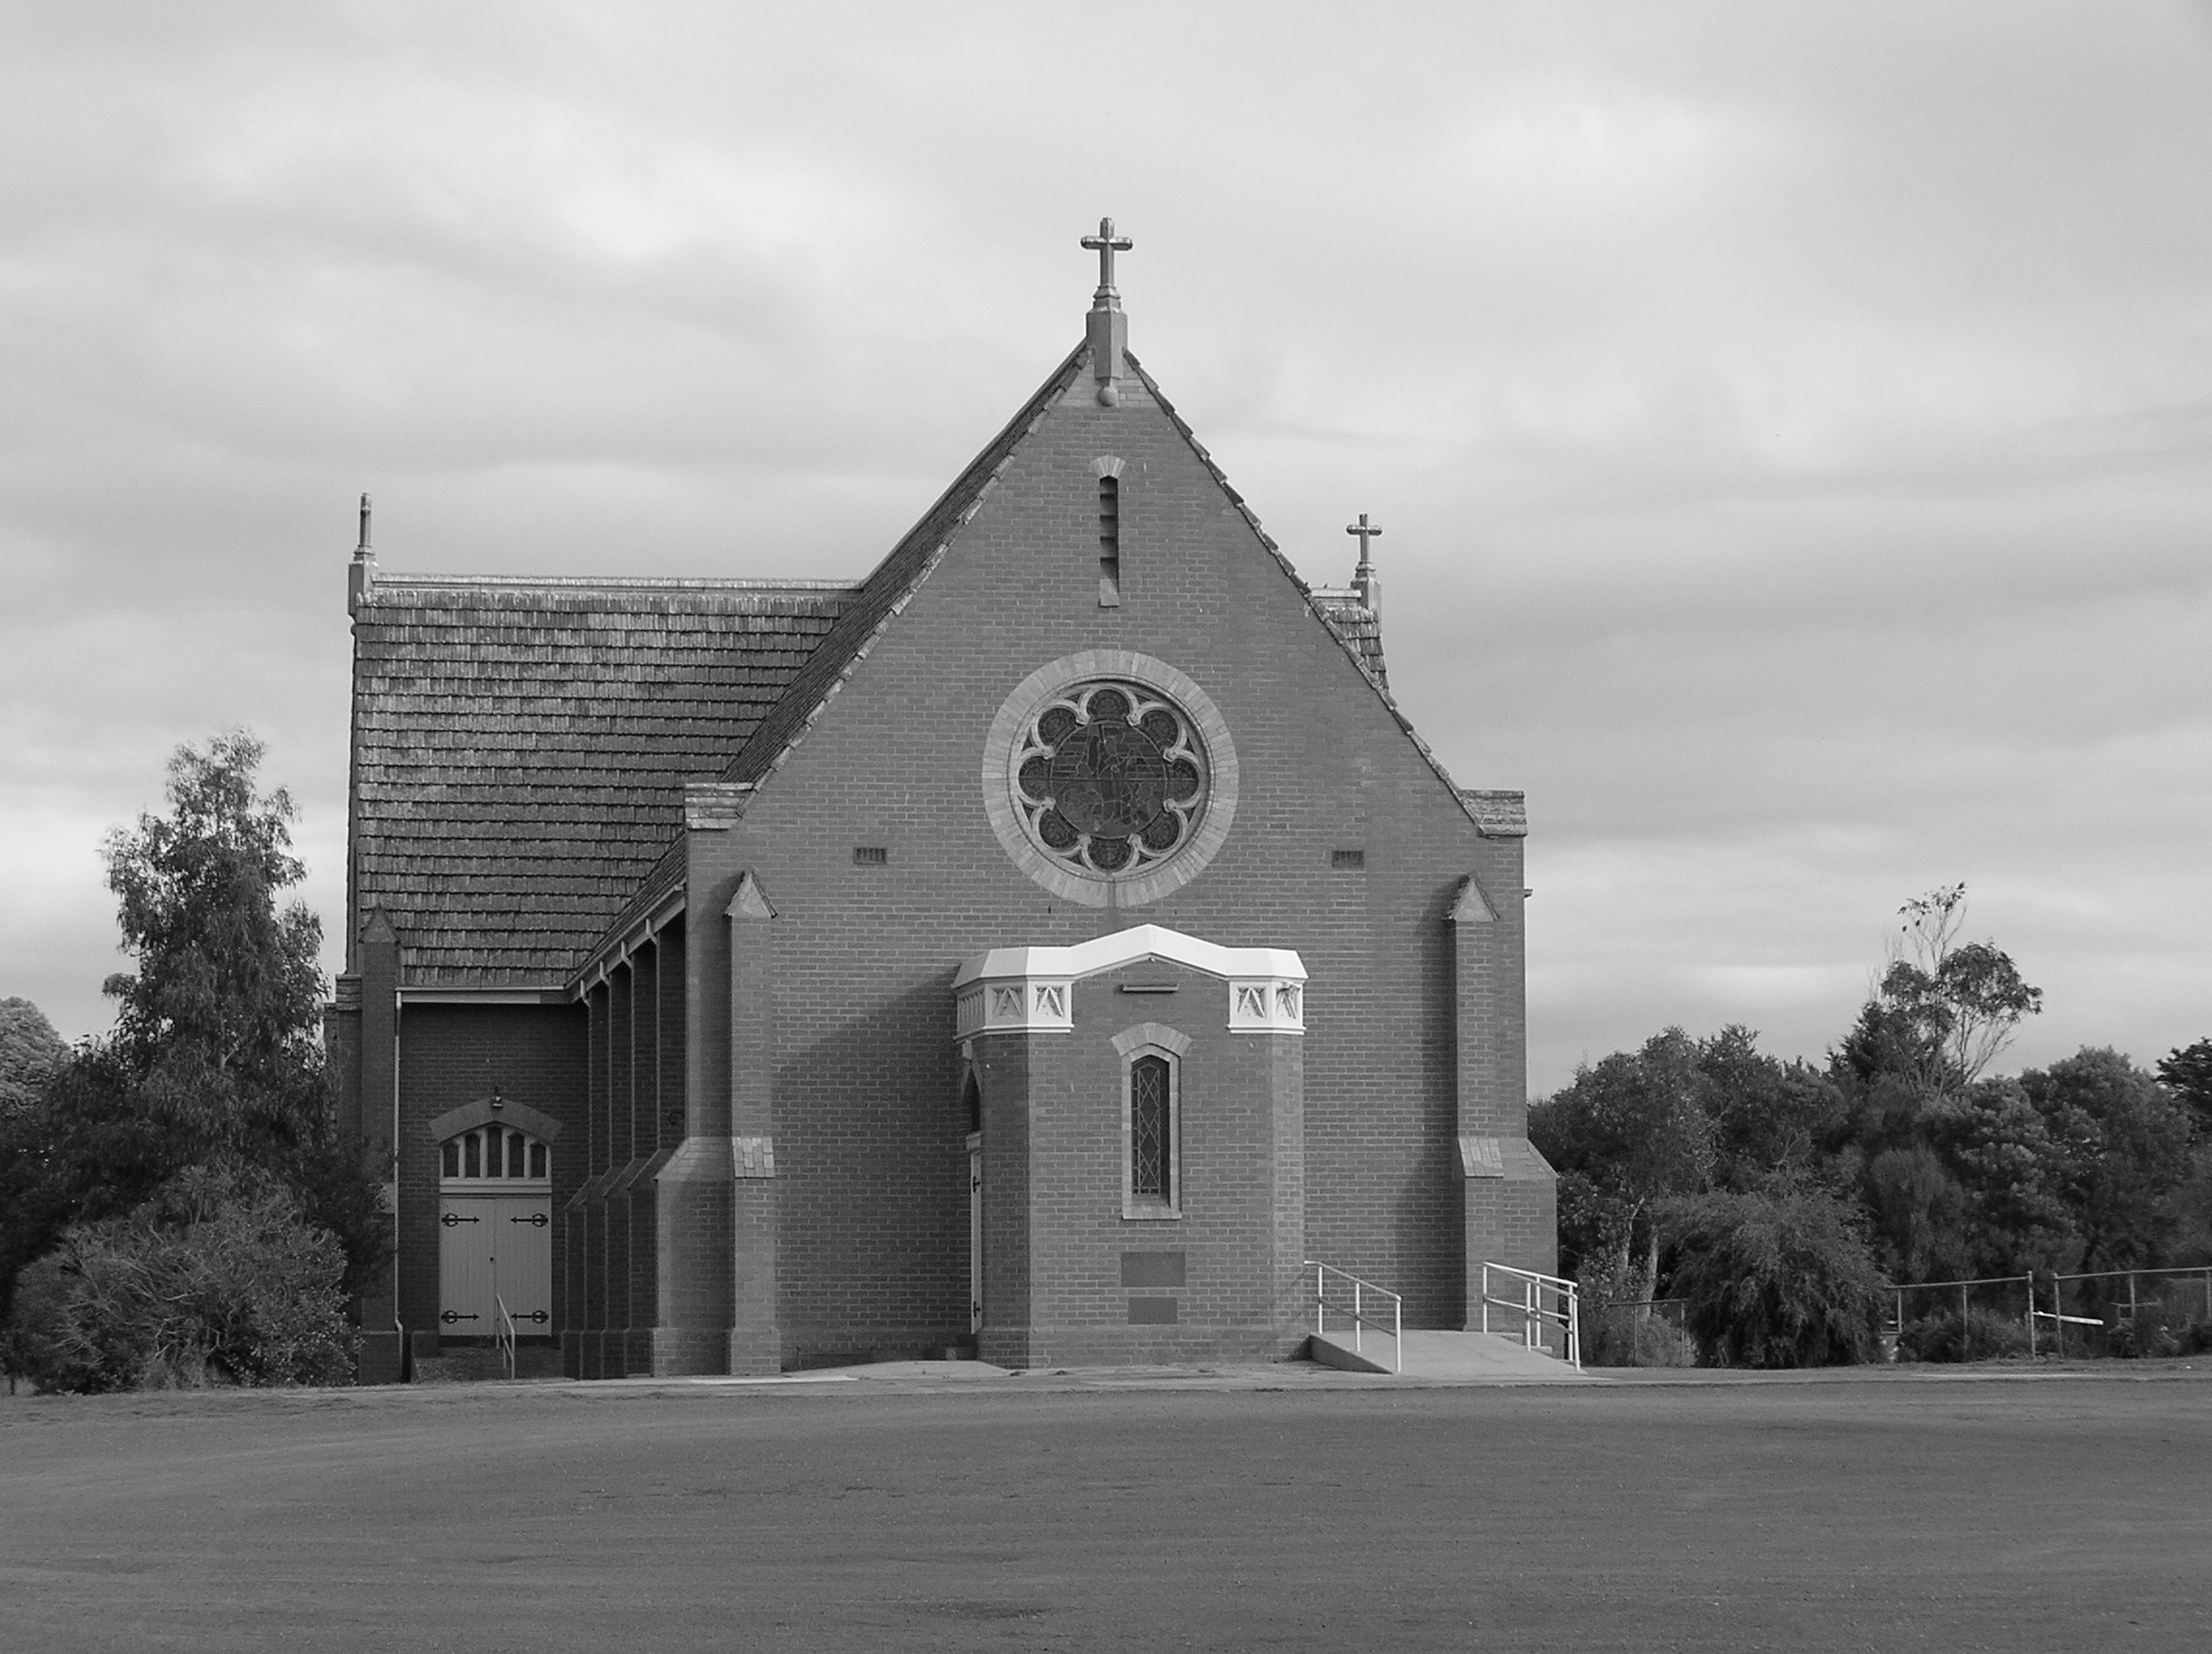
The communities of St. Brendan’s and St. Joseph’s in the Parish of Cororooke warmly welcome you all, especially visitors who have joined us for the celebration of the Centenary of our Parish. We have experienced the faith and commitment of the people who have made St. Brendan’s Parish part of their life story – part of their sacred story. Our places of worship hold the joys and sorrows of many who have gathered to celebrate in prayer and song. What has been given to us will be part of the next generation.
As we greet friends and gather in prayer today, let us remember with gratitude those who gave so much of their time and care to our Parish. Our challenge is to continue “the story they wrote”.

Parish of Cororooke.
P O Box 27, Cororooke 3254.
Phone: 5233 1282.
Email: cororooke@ballarat.catholic.org.au
Parish Sec: Trish Hickey 52314667/0428031340

Moderator: Liz McGuane 52331222 0427041072
Visiting Priest: -
School Principal: Anne Ruddell. 52331464.
St Brendan’s: 9.30am Sunday.
St Joseph’s: 10.30am Sunday.

ST. BRENDAN’S: 27th May @ 9.30am.
Commentator: R. O’Dowd
Reader: L. Darcy
Musician: J. O’Dowd
Communion: B. Newcombe
Lay Leader:
Procession of Gifts: T. D’Altera

ST.JOSEPH’S 27th May @10.30am.
Family: Gibson
Communion H. Gibson
Lay Leaders:
ALTAR & SACRISTY DUTIES:
St.Joseph’s:
May: Convery/Oborne
June: Everett/Manson

St.Brendan’s;
May 27-June 3: J Dimasi/D Sutherland
Jun 10^{th/17th} June: C. Finlay/T. Hickey

COUNTERS;
20 May: J Finlay
3 June: L Darcy
RECENT DEATHS:

SICK: Fr. Brian Russell, Loretta Kervin
Nathan De Lorenzo, Peter Stewart, Helen Hunt,
Courtney McLennan, Mitchell Johnstone, Maddi Allardyce.


ANNIVERSARIES May: Dorothy Donovan, Jill Halloran, Joy Evans, Jack Ryan, John Armstrong, Norah Russell, Damian Black, John Gorwell, Tim McCarthy, Frank Monaco, Pat Murnane, Margaret O’Shea, Norma Clifford, Kathleen Denning, Tony Sproules, Betty O’Brien, Maureen Martin, Mary Lloyd, Mick Nash, Rita O’Brien, Frank Garner, Patricia Whytcross, Roy Quigley, Agnes Hickey, Bill Mahoney (jnr), Thomas Russell, Br Kevin Tuck.

PRAYER OF ST. BRENDAN.
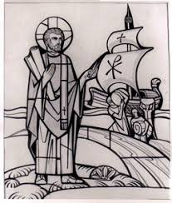
“Help me to journey beyond the familiar and into the unknown. Give me the faith to leave old ways and break fresh ground with you.

Parish Leadership team News
We are pleased to announce Maureen Finn and Michelle Carmody have accepted the invitation to join the PLT. Maureen has spent many years serving on the Finance team and Michelle is our Baptism Co-ordinator so we thank them for their generosity in accepting their roles. Also thank you to Ann Maree Convery and Ann McCarthy for agreeing to take on an extra. 12 mths. We would like to thank Jim Finlay and Liz McGuane for their dedicated service.

SCHOOL:
Fruit tree pruning workshop: Please note the change of date. This is now scheduled for Saturday 16th of June in the school orchard. This workshop will cover pruning young fruit trees, pruning mature fruit trees, different pruning styles and pruning roses. There will also be an opportunity to discuss grafting and beekeeping. The workshop will begin at 10.00. Gold coin donation.

Grow and Swap Keep the fruit/veggies coming. Feel free to add produce to our Grow and Swap. A gold coin donation box will be placed there for people wishing to purchase some fresh produce. The gold coin will then go into the school gardening. .Lemons are going like hotcakes.

Come, Look See: Over the next coming weeks we will be preparing for our open morning and afternoon. The date has been set for Tuesday the 22nd of May. This year we will be having an open morning and afternoon session.

Clean Out.
Final cleanout of the Presbytery will be conducted after Mass on 3rd June. Your help will be appreciated.

