
Sunday, 3rd July, 2016.
14th Sunday in Ordinary Time!
Year C.

First Reading Is 66:10-14 A reading from the prophet Isaiah I will send toward Jerusalem peace like a river. Rejoice, Jerusalem, be glad for her, all you who love her! Rejoice, rejoice for her, all you who mourned her! That you may be suckled, filled, from her consoling breast, that you may savour with delight her glorious breasts. For thus says the Lord: Now towards her I send flowing peace, like a river, and like a stream in spate the glory of the nations. At her breast will her nurslings be carried and fondled in her lap. Like a son comforted by his mother will I comfort you. And by Jerusalem you will be comforted. At the sight your heart will rejoice, and your bones flourish like the grass. To his servants the Lord will reveal his hand. The word of the Lord.
Responsorial Psalm Ps 65:1-7. 16. 20. R. v.1 (R.) Let all the earth cry out to God with joy.
1. Cry out with joy to God all the earth, O sing to the glory of his name. O render him glorious praise. Say to God: ‘How tremendous your deeds! (R.)
2. ‘Before you all the earth shall bow; shall sing to you, sing to your name!’ Come and see the works of God, tremendous his deeds among men. (R.)
3. He turned the sea into dry land, they passed through the river dry-shod. Let our joy then be in him; he rules for ever by his might. (R.)
4. Come and hear, all who fear God. I will tell what he did for my soul. Blessed be God who did not reject my prayer nor withhold his love from me. (R.)
Second Reading Gal 6:14-18 A reading from the letter of St Paul to the Galatians The marks I carry on my body are those of Jesus Christ. The only thing I can boast about is the cross of our Lord Jesus Christ, through whom the world is crucified to me, and I to the world. It does not matter if a person is circumcised or not; what matters is for him to become an altogether new creature. Peace and mercy to all who follow this rule, who form the Israel of God. I want no more trouble from anybody after this; the marks on my body are those of Jesus. The grace of our Lord Jesus Christ be with your spirit, my brothers. Amen. The word of the Lord.

Gospel Acclamation Col 3:15. 16 Alleluia, alleluia! May the peace of Christ rule in your hearts, and the fullness of his message live within you. Alleluia!

Gospel Lk 10:1-12, 17-20 A reading from the holy Gospel according to Luke Your peace will rest upon him. The Lord appointed seventy-two others and sent them out ahead of him, in pairs, to all the towns and places he himself was to visit. He said to them, ‘The harvest is rich but the labourers are few, so ask the Lord of the harvest to send labourers to his harvest. Start off now, but remember, I am sending you out like lambs among wolves. Carry no purse, no haversack, no sandals. Salute no one on the road. Whatever house you go into, let your first words be, “Peace to this house!” And if a man of peace lives there, your peace will go and rest on him; if not, it will come back to you. Stay in the same house, taking what food and drink they have to offer, for the labourer deserves his wages; do not move from house to house. Whenever you go into a town where they make you welcome, eat what is set before you. Cure those in it who are sick, and say, “The kingdom of God is very near to you.” But whenever you enter a town and they do not make you welcome, go out into its streets and say, “We wipe off the very dust of your town that clings to our feet, and leave it with you. Yet be sure of this: the kingdom of God is very near.” I tell you, that on that day it will not go as hard with Sodom as with that town.’ The seventy-two came back rejoicing. ‘Lord,’ they said, ‘even the devils submit to us when we use your name.’ He said to them, ‘I watched Satan fall like lightning from heaven. Yes, I have given you power to tread underfoot serpents and scorpions and the whole strength of the enemy; nothing shall ever hurt you. Yet do not rejoice that the spirits submit to you; rejoice rather that your names are written in heaven.’ The Gospel of the Lord.

RECENT DEATHS: Fred Bentley ,
Rita Monahan(Karen Slater’s Mum)

ANNIVERSARIES:
Paddy Finn. Les Goonan. Jeff Holt, Peter Lineen. Sheila Russell

SICK: Lorraine Russell, Loretta Kervin, Nathan DeLorenzo, Peter Stewart,
Helen Hunt, Margaret Sinclair,
Courtney McLennan, Michelle Smith.

Altar Servers and Projectionists.
Children are welcome to participate they will be supported by an adult if required. See Lucy Darcy.

WELCOME.
Parish of Cororooke.
P O Box 27, Cororooke 3254.
Phone: 5233 1282.

Moderator: Lucy Darcy 52331228.
Visiting Priest: Fr Dan Arundell
(Sacramental responsibility for our communities including Baptisms, Wedding & Funerals). 53387804.
School Principal: Anne Ruddell. 52331464.
St Brendan’s: 9.00am Sundays.
St Joseph’s: 10.30am Sundays.

ST BRENDAN’S: (9.00am 10th July, 2016)
Communion Minister: M Allan
Commentator: M Carmody
Reader: J Miller
Organist: J O’Dowd
Procession Gifts: Emily Lenehan
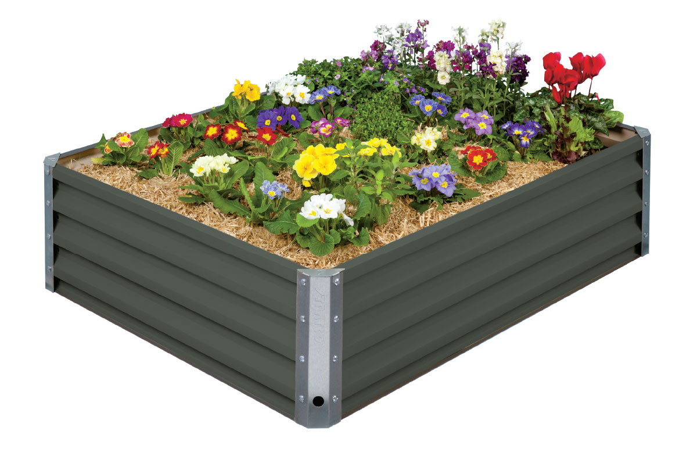
Lay Leaders:

ST. JOSEPH’S: 10.30am
Communion Minister: R Whytcross
Family: G&M Carmody
Lay Leaders .

ALTAR & SACRISTY DUTIES:
St Joseph’s:
July: McCormick.
August: B. & K. McGuane

St Brendan’s:
10th/17th July K. McKay / M.Mahoney
24th/31st July J Dimasi/D Sutherland

COUNTERS:
This week: N McKay
Counters please note. Starting July money only needs counting every 2nd weekend!
Liturgy Preparation Roster:
July: Caroline Grist/Jill O’Dowd.
Aug: Liz. Anne, Marg

Dates to Remember.
10th August: Finance Meeting. 8.00pm.
11th August: Leadership Meeting. 7.30pm.

KEEP THIS DATE FREE.
On Sunday, 24th July, Fr Dan celebrates his Diamond Jubilee of Ordination. Mass will be
followed by a shared luncheon in the School Hall. More details to follow.

TOUR OF ST BRENDAN’S SCHOOL
Enrolment tours are still available for Parents who are considering sending their child/children to our school. Should you be aware of anyone with a school age child please mention to them tours are available by appointment. Contact Anne Ruddell 52331464.

Register of Parish Volunteers
At the back of both churches are signature sheets to capture names of parishioners who undertake various volunteer activities. The register has been set up for 2016-2018 They will be available for individuals to complete throughout July. Thank you for your support in this.

Cuttings wanted for school garden! Please leave at the School.

BIRTHDAY WISHES:
July 7th Jack McCarthy 80 yrs young


ANNUAL COLLECTION FOR THE POPE –WEEKEND OF JUNE 25/26or JULY 2/3, 2016.

Once again the Annual Collection for the Holy Father is to be taken up throughout the world on a weekend near the Feast of Ss. Peter & Paul (29th June 2015). The collection will be taken up in this Diocese on the weekend of June 25/26 or July 2/3 next.
I am aware of the many demands made on the people of our Diocese throughout the year by way of appeals for financial support. However, this particular Appeal does require special attention.
Through this collection we have the opportunity of supporting the Pope’s pastoral care for people around the world.
I commend the 2016 Appeal to you and your parishioners.
Yours in Christ,
Paul Bird CSsR
Bishop of Ballarat

