6/05/2018.
6th Sunday of Easter.

First Reading Acts 10:25-26. 34-35. 44-48 The gift of the Holy Spirit was poured out upon the gentiles also. As Peter reached the house Cornelius went out to meet him, knelt at his feet and prostrated himself. But Peter helped him up. ‘Stand up,’ he said, ‘I am only a man after all!’ Then Peter addressed them: ‘The truth I have now come to realise’ he said, ‘is that God does not have favourites, but that anybody of any nationality who fears God and does what is right is acceptable to him.’ While Peter was still speaking the Holy Spirit came down on all the listeners. Jewish believers who had accompanied Peter were all astonished that the gift of the Holy Spirit should be poured out on the pagans too, since they could hear them speaking strange languages and proclaiming the greatness of God. Peter himself then said, ‘Could anyone refuse the water of baptism to these people, now they have received the Holy Spirit just as much as we have?’ He then gave orders for them to be baptised in the name of Jesus Christ. Afterwards they begged him to stay on for some days.

Responsorial Psalm Ps 97:1-4. R. see v.2
(R.) The Lord has revealed to the nations his saving power.
1. Sing a new song to the Lord for he has worked wonders. His right hand and his holy arm have brought salvation. (R.)
2. The Lord has made known his salvation; has shown his justice to the nations. He has remembered his truth and love for the house of Israel. (R.)
3. All the ends of the earth have seen the salvation of our God. Shout to the Lord all the earth, ring out your joy. (R.)

Second Reading 1 Jn 4:7-10 God is love. My dear people, let us love one another since love comes from God and everyone who loves is begotten by God and knows God. Anyone who fails to love can never have known God, because God is love. God’s love for us was revealed when God sent into the world his only Son so that we could have life through him; this is the love I mean: not our love for God, but God’s love for us when he sent his Son to be the sacrifice that takes our sins away.

Gospel Acclamation Jn 14:23 Alleluia, alleluia! All who love me will keep my words, and my Father will love them and we will come to them. Alleluia!

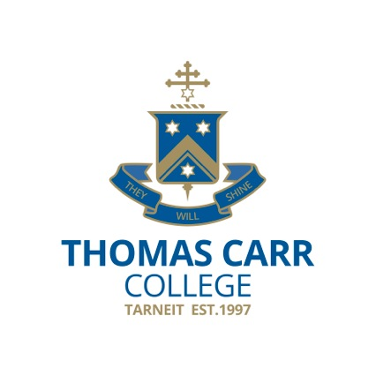
Gospel Jn 15:9-17 No one can have greater love than to lay down his life for his friends. Jesus said to his disciples: ‘As the Father has loved me, so I have loved you. Remain in my love. If you keep my commandments you will remain in my love, just as I have kept my Father’s commandments and remain in his love. I have told you this so that my own joy may be in you and your joy be complete. This is my commandment: love one another, as I have loved you. A man can have no greater love than to lay down his life for his friends. You are my friends, if you do what I command you, I shall not call you servants any more, because a servant does not know his master’s business; I call you friends, because I have made known to you everything I have learnt from my Father. You did not choose me, no, I chose you; and I commissioned you to go out and to bear fruit, fruit that will last; and then the Father will give you anything you ask him in my name. What I command you is to love one another.’

We welcome all visitors from Thomas Carr College to our Parish today.

REFLECTION; A pagan Roman officer was so evidently graced by the Holy Spirit that St Peter realised that the followers of Jesus Christ need not be constrained within the confines of Judaism. This incident, together with St Paul’s mission, has helped Christianity spread to every tribe and nation on the face of the earth.
‘Catholic’ simply means ‘world wide’, and the Church’s universal mission is to preach the truth of Christ’s victory over death and the true meaning of love: ‘No greater love can a man have than to lay down his life for his friend.’
In our experience, this is best exemplified in the desire of a mother or father to substitute themselves for a dying infant or child. Our Lord practised what he preached with incredible intensity. He substituted himself for the whole of humanity dying because of a broken relationship with its Creator. He did so on behalf of us whom he calls friends, those with whom he wishes to share his victory over death.
This is the message entrusted to the members of the one, holy, catholic and apostolic church to be spread to the people of every tribe and nation.
We could take a moment to pray that we better express our undying gratitude for our status as friends of the Risen Lord, and better do our part as missionary disciples spreading the news of his great love embracing the whole of humanity.
© Fr Michael Tate

Parish of Cororooke.
P O Box 27, Cororooke 3254.
Phone: 5233 1282.
Email: cororooke@ballarat.catholic.org.au
Parish Sec: Trish Hickey 52314667/0428031340

Moderator: Liz McGuane 52331222 0427041072
Visiting Priest: -
School Principal: Anne Ruddell. 52331464.
St Brendan’s: 9.30am Sunday.
St Joseph’s: 10.30am Sunday.

ST. BRENDAN’S: 13th May @ 9.30am.
Commentator: M. McCarthy
Reader: C. Finlay
Musician: L. McGuane
Communion: J. O’Dowd
Lay Leader:
Procession of Gifts: Andrew Dimasi.

ST.JOSEPH’S 13th May @10.30am.
Family: M. Carmody
Communion: M.Carmody
Lay Leaders:
ALTAR & SACRISTY DUTIES:
St.Joseph’s:
May: Convery/Oborne
June: McCormick

St.Brendan’s;
April 29th/May 6th: C. Ryan/K. O’Donnell.
May 13th/20th: K. Speirs/D. McCarthy

COUNTERS;
6 May : N McKay
20 May: J Finlay
RECENT DEATHS:

SICK: Fr. Brian Russell, Loretta Kervin
Nathan De Lorenzo, Peter Stewart, Helen Hunt,
Courtney McLennan, Mitchell Johnstone,
Maddi Allardyce, Ross Suares.

ANNIVERSARIES May:
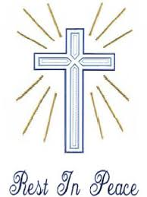
Dorothy Donovan, Jill Halloran, Joy Evans, Jack Ryan, John Armstrong, Norah Russell, Damian Black, John Gorwell, Tim McCarthy, Frank Monaco, Pat Murnane, Margaret O’Shea, Norma Clifford, Kathleen Denning, Tony Sproules, Betty O’Brien, Maureen Martin, Mary Lloyd, Mick Nash, Rita O’Brien, Frank Garner, Patricia Whytcross, Roy Quigley, Agnes Hickey, Bill Mahoney (jnr), Thomas Russell, Br Kevin Tuck.


TODAY .The Colac Catholic Women’s League is holding a fundraiser screening of the movie ‘Mary Magdalene’ at Colac Cinemas at 2pm. Tickets are available at the box office at Colac Cinemas. Afternoon Tea provided. All tickets $15.

DATES TO REMEMBER;
- 13th May. Official Mass Count.
St Brendan’s Mass 9:30
St Joseph’s Mass 10:30.

- 20th May @ 10am. Commissioning Mass and Celebration of 100yrs since the establishment of the Parish of Cororooke@ St Brendan’s. Mass will be followed with light refreshments in the hall. All Welcome.
St Joseph’s NO MASS.

Timorese Appeal. There is an appeal currently being held to collect our pre-loved reading glasses. If you have any at your home could you please leave them at the back of either Church.

Bishop Paul asks us to reflect on these two questions for the “Plenary Council”
“What is your experience of Church?”
“What would you like to see as Church in the future?” Pope Francis is convinced that it is by listening to one another that we listen to God and that “open and fraternal debate makes theological and pastoral thought grow”. He is also convinced in the power of fact to face encounter.. We need one another all being well, if we can learn to speak boldly listen humbly and always with an open prayerful heart we may not only learn what the spirit wants for us but also to respect and even enjoy one another. The official launch for the Australian Plenary Council will be on Pentecost Sunday, 2018.

