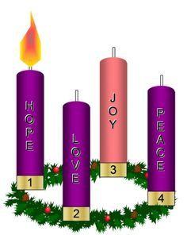
Sunday, 3rd Dec,
1st Sunday of Advent!

3rd December. Community Celebration of Forgiveness immediately after Lay Led.
10th Dec: End Of School Mass.
17th Dec: Carols in Church 7pm all welcome.
23rd Dec: Lay Led 4th Sunday of Advent 7pm St Brendan’s.
Christmas Masses:
Christmas Eve St Brendan’s: 7pm
Christmas Day St Joseph’s : 10am.

First Reading Is 63:16-17; 64:1.3-8 Oh that you would tear the heavens apart and come down. You, Lord, yourself are our Father, Our Redeemer is your ancient name. Why, Lord, leave us to stray from your ways and harden our hearts against fearing you? Return, for the sake of your servants, the tribes of your inheritance. Oh, that you would tear the heavens open and come down – at your Presence the mountains would melt. No ear has heard, no eye has seen any god but you act likethis for those who trust him. You guide those who act with integrity and keep your ways in mind. You were angry when we were sinners; we had long been rebels against you. We were all like men unclean, all that integrity of ours like filthy clothing. We have all withered like leaves and our sins blew us away like the wind. No one invoked your name or roused himself to catch hold of you. For you hid your face from us and gave us up to the power of our sins. And yet, Lord, you are our Father; we the clay, you the potter, we are all the work of your hand.

Responsorial Psalm Ps 79:2-3. 15-16. 18-19 R. v.4 R. Lord, make us turn to you, let us see your face and we shall be saved.
1. O shepherd of Israel, hear us, shine forth from your cherubim throne. O Lord, rouse up your might, O Lord, come to our help. (R.)
2. God of hosts, turn again, we implore, look down from heaven and see. Visit this vine and protect it, the vine your right hand has planted. (R.)
3. May your hand be on the man you have chosen, the man you have given your strength. And we shall never forsake you again: give us life that we may call upon your name. (R.)

Second Reading 1 Cor 1:3-9 The revelation we looked for, Christ Jesus our Lord. May God our Father and the Lord Jesus Christ send you grace and peace. I never stop thanking God for all the graces you have received through Jesus Christ. I thank him that you have been enriched in so many ways, especially in your teachers and preachers; the witness to Christ has indeed been strong among you so that you will not be without any of the gifts of the Spirit while you are waiting for our Lord Jesus Christ to be revealed; and he will keep you steady and without blame until the last day, the day of our Lord Jesus Christ, because God by calling you has joined you to his Son, Jesus Christ; and God is faithful.

Gospel Acclamation Ps 84:8 Alleluia, alleluia! Lord, show us your mercy and love, and grant us your salvation. Alleluia!

Gospel Mk 13:33-37. Stay awake! You never known when the Lord will come. Jesus said to his disciples: ‘Be on your guard, stay awake, because you never know when the time will come. It is like a man travelling abroad: he has gone from home, and left his servants in charge, each with his own task; and he has told the doorkeeper to stay awake. So stay awake, because you do not know when the master of the house is coming, evening, midnight, cockcrow, dawn; if he comes unexpectedly, he must not find you asleep. And what I say to you I say to all: Stay awake.

Lighting the 1st Advent Candle.

We light this candle for all God”s people, struggling to be bearers of hope in a troubled world.
ALL: God, as we wait for your promise, give light, give hope.

WELCOME.
Parish of Cororooke.
P O Box 27, Cororooke 3254.
Phone: 5233 1282.
Email: cororooke@ballarat.catholic.org.au
Parish Sec: Trish Hickey 52314667/0428031340

Moderator: Liz McGuane 52331222 0427041072
Visiting Priest: -
School Principal: Anne Ruddell. 52331464.
St Brendan’s: 9.00am Sunday.
St Joseph’s: 10.30am Sunday.

ST. BRENDAN’S: Sunday 10th Dec, @ 9.30am.
Commentator: J. Miller
Reader: Lachie Speirs
Communion: B. Newcombe
Organist: J. O’Dowd Procession of gifts: Lucas Ruddell
Lay Leader:

ST.JOSEPH’S Sunday 10th Dec, @10.30am.
Family: McCormick
Communion: J. Sherman
Lay Leaders:
ALTAR & SACRISTY DUTIES:
St. Joseph’s:
December : D Melville.
January: K. Slater. St. Brendan’s;
10th/17th Dec: M. Finn/M.Carmody.
24th/31st Dec: L. McGuane/A. Swanson.
COUNTERS;
3rd Dec: J. Finlay
17th Dec: L. Darcy

RECENT DEATHS: Hilary Kavenagh.

ANNIVERSARIES: Lorraine Russell, Nell Matthews, Jake Inglis, A. Olney, Sr M. Ryan, Vera
Brown.

SICK: Fr. Brian Russell, Loretta Kervin
Nathan De Lorenzo, Peter Stewart, Helen Hunt, Courtney McLennan, Mitchell Johnstone, Maddi Allardyce.

PLEASE NOTE!! From now on Mass and Lay leds’ at St Brendan’s will be at 9:30am on Sunday mornings.

t3 Advent Calendar App
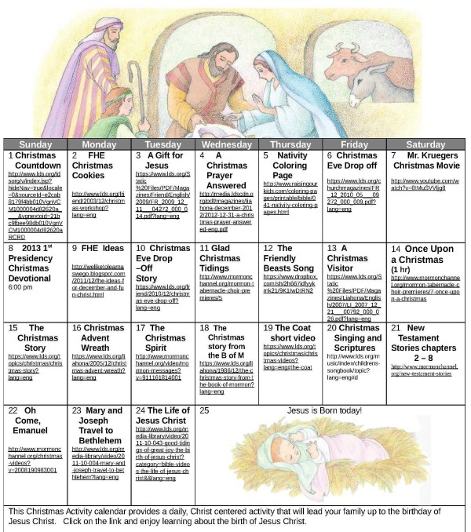
The 2017 Xt3 Advent Calendar App and Website FREE and available. The first door of the Calendar will open on December 3, 2017, the first Sunday of Advent. Go to: http://www.xt3.com/advent/ to download.

YEAR OF YOUTH.
The Australian Bishops have identified the liturgical year of 2018, beginning on the first Sunday of Advent as a national Year of Youth. The theme of the Year of Youth is Open New Horizons for Spreading Joy.
Week 1:
All: Come Holy Spirit of this great Southland.
Inspire our entire faith community, as we prayerfully discern new horizons for spreading joy in the lives and communities of the people of God.

EARLY WARNING NOTICE:
Mass times for the last weekend in January. For this weekend only.
St Joseph’s: 10.00am
St Brendan’s: 11.00am

Thank You;
- Sunday 10th December, The Knights of the Southern Cross will clean the windows at both Churches.

- Delahunty family extend their thanks to our Community for our support at the time of the Irma’s passing.

Advent Prayer:
Eternal God, we are seeking signs of your presence in our lives. Open our eyes, our ears and our hearts to receive some word of hope as we anticipate the coming of the one whom you are sending.

