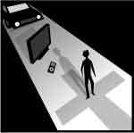
Sunday, 4th Sept, 2016.
23rd Sunday in Ordinary Time. Year C.

First Reading Wis 9:13-18 A reading from the book of Wisdom. Who can comprehend the will of God? What man can know the intentions of God? Who can divine the will of the Lord? The reasonings of mortals are unsure and our intentions unstable; for a perishable body presses down the soul, and this tent of clay weighs down the teeming mind. It is hard enough for us to work out what is on earth, laborious to know what lies within our reach; who, then, can discover what is in the heavens? As for your intention, who could have learnt it, had you not granted Wisdom and sent your holy spirit from above? Thus have the paths of those on earth been straightened and men been taught what pleases you, and saved, by Wisdom. The word of the Lord.

Responsorial Psalm Ps 89:3-6.12-14. 17. R. v.1 (R.) In every age, O Lord, you have been our refuge.
1. You turn men back into dust and say: ‘Go back, sons of men.’ To your eyes a thousand years are like yesterday, come and gone, no more than a watch in the night. (R.)
2. You sweep men away like a dream, like grass which springs up in the morning. In the morning it springs up and flowers: by evening it withers and fades. (R.)
3. Make us know the shortness of our life that we may gain wisdom of heart. Lord, relent! Is your anger for ever? Show pity to your servants. (R.) 4. In the morning, fill us with your love; we shall exult and rejoice all our days. Let the favour of the Lord be upon us: give success to the work of our hands. (R.)

Second Reading Phlm 9-10, 12-17 A reading from the letter of St Paul to Philemon. Receive him, not as a slave anymore, but as a very dear brother. This is Paul writing, an old man now and, what is more, still a prisoner of Christ Jesus. I am appealing to you for a child of mine, whose father I became while wearing these chains: I mean Onesimus. I am sending him back to you, and with him – I could say – a part of my own self. I should have liked to keep him with me; he could have been a substitute for you, to help me while I am in the chains that the Good News has brought me. However, I did not want to do anything without your consent; it would have been forcing your act of kindness, which should be spontaneous. I know you have been deprived of Onesimus for a time, but it was only so that you could have him back for ever, not as a slave any more, but something much better than a slave, a dear brother; especially dear to me, but how much more to you, as a bloodbrother as well as a brother in the Lord. So if all that we have in common means anything to you, welcome him as you would me. The word of the Lord.

Gospel Acclamation Ps 118:135 Alleluia, alleluia! Let your face shine on your servant, and teach me your laws. Alleluia!

Gospel Lk 14:25-33 A reading from the holy Gospel according to Luke. All who do not renounce their possessions cannot be my disciples. Great crowds accompanied Jesus on his way and he turned and spoke to them. ‘If any man comes to me without hating his father, mother, wife, children, brothers, sisters, yes and his own life too, he cannot be my disciple. Anyone who does not carry his cross and come after me cannot be my disciple. ‘And indeed, which of you here, intending to build a tower, would not first sit down and work out the cost to see if he had enough to complete it? Otherwise, if he laid the foundation and then found himself unable to finish the work, the onlookers would all start making fun of him and saying, “Here is a man who started to build and was unable to finish.” Or again, what king marching to war against another king would not first sit down and consider whether with ten thousand men he could stand up to the other who advanced against him with twenty thousand? If not, then while the other king was still a long way off, he would send envoys to sue for peace. So in the same way, none of you can be my disciple unless he gives up all his possessions.’ The Gospel of the Lord.

RECENT DEATHS.

SICK: Lorraine Russell, Loretta Kervin, Nathan DeLorenzo, Peter Stewart, Helen Hunt, Margaret Sinclair, Courtney McLennan, Mike Ebeling, Amber Bayne, Vin Malone.

ANNIVERSARIES: Stan Milligan, Ken Turner, Lyla Ryan, Joan Page, Rex Delahunty, Ellan Dolan, Bob Russell,

WELCOME.
Parish of Cororooke.
P O Box 27, Cororooke 3254.
Phone: 5233 1282.

Moderator: Lucy Darcy 52331228.
Visiting Priest:
School Principal: Anne Ruddell. 52331464.
St Brendan’s: 9.00am Sundays.
St Joseph’s: 10.30am Sundays.

ST BRENDAN’S: 11th Sept, 2016 9.00am.
Communion Minister: Brigid Newcombe
Commentator: M. Allan
Reader: Caroline Grist.
Organist: J. O’Dowd
Procession Gifts Poppy Donovan
Lay Leaders:

ST. JOSEPH’S: 10:30 am
Communion Minister: J.Sherman
Family: L. Darcy
Lay Leaders

ALTAR & SACRISTY DUTIES:
St Joseph’s:
Sept: Ryan /Gibson.
Oct : Mulheron/Sherman

ST BRENDAN’S:
4th/11th Sept: A Bayne/ M McGee.
18th/25th Sept: M Carmody/M Finn

COUNTERS:
Next week: C. Finlay. 4th Sept
Counters please note. Money is to be counted every 2nd weekend.

Liturgy Preparation Roster:
Sept: Marita & Carmel.
Oct: Ros & Bronwyn.

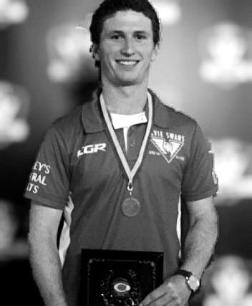
Congratulations to Liam McGuane, who won the Jack Mahoney Medal for the CDFL 2016 Best and Fairest.
A well deserved honour.

Marriage: Please remember in prayer those in our parish preparing for the sacrament of marriage –
Robert O’Shea & Charlotte Kavenagh, September 17th, St. Brendan’s at 2.00pm and Anthony Whytcross & Tracey Richardson, November 12th at St. Joseph’s.
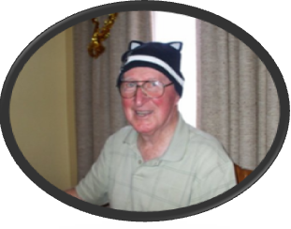
From Fr Dan,
My friends,
Words cannot express how much I appreciated your messages of farewell and good wishes on my Diamond Jubilee of Ordination.
I would love to write to you individually but I know you will understand that is not possible. I have read and re-read the many cards I received and the beautiful message read at the end of Mass.
I will always remember each of you in the places where you sat during Mass at Cororooke and Pirron Yallock. I love you all dearly,
Thanks,
Dan Arundell.

Happy Fathers Day to all
our wonderful Dads!
Mother to young son: ‘Why are you crying?’
Son: ‘Daddy hit his hand with a hammer.’
Mother: ‘I’m surprised you’re not laughing.’
Son: ‘I did.'

A Father's Day Prayer

Let us praise those fathers who have striven to balance the demands of work, marriage, and children with an honest awareness of both joy and sacrifice
Let us praise those fathers who, lacking a good model for a father, have worked to become a good father.
Let us praise those fathers who by their own account were not always there for their children, but who continue to offer those children, now grown, their love and support.
Let us pray for those fathers who have been wounded by the neglect and hostility of their children.
Let us praise those fathers who, despite divorce, have remained in their children's lives.
Let us praise those fathers whose children are adopted, and whose love and support has offered healing.
Let us praise those fathers who, as stepfathers, freely choose the obligation of fatherhood and earned their step children's love and respect.
Let us praise those fathers who have lost a child to death, and continue to hold the child in their heart.
Let us praise those men who have no children, but cherish the next generation as if they were their own.
Let us praise those men who have "fathered" us in their role as mentors and guides.
Let us praise those men who are about to become fathers; may they openly delight in their children.
And let us praise those fathers who have died, but live on in our memory and whose love continues to nurture us.
Kirk Loadman

