FR DAN ARUNDELL
Diamond Jubilee of
Religious Life.
1956-2016.
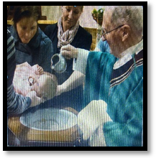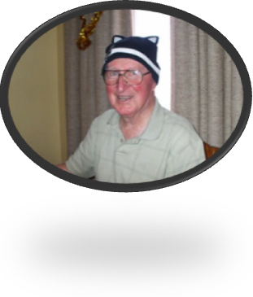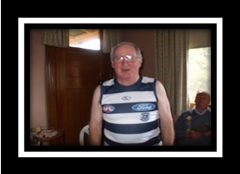



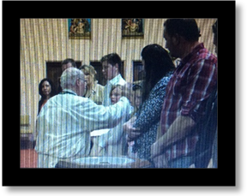

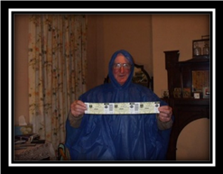


24th July, 2016.
17th Sunday in Ordinary Time!
Year C.
WELCOME.
Parish of Cororooke.
P O Box 27, Cororooke 3254.
Phone: 5233 1282.

Moderator: Lucy Darcy 52331228.
Visiting Priest: Fr Dan Arundell
(Sacramental responsibility for our communities including Baptisms, Wedding & Funerals). 53387804.
School Principal: Anne Ruddell. 52331464.
St Brendan’s: 9.00am Sundays.
St Joseph’s: 10.30am Sundays.

ST BRENDAN’S: (9.00am 31st July, 2016)
Communion Minister: M. O’Shea
Commentator: A. McCarthy
Reader: M. Finn
Organist:
Procession Gifts:
Lay Leaders: K. O’Donnell/L.Darcy

ST. JOSEPH’S: 10.30am 31st July, 2016.
Communion Minister E. Smith
Family: McCormick
Lay Leaders C & C Grist.

ALTAR & SACRISTY DUTIES:
St Joseph’s:
July: McCormick.
August: B. & K. McGuane

St Brendan’s:
24th/31st July J Dimasi/D Sutherland
7th /14th August T Hickey/C Finlay

COUNTERS:
Next week: L Darcy 24/07
Counters please note. Starting July money only needs counting every 2nd weekend!

Liturgy Preparation Roster:
Aug: Liz. Anne, Marg.

Dates to Remember.
10th August: Finance Meeting. 8.00pm.
11th August: Leadership Meeting. 7.30pm.
14th August: Thomas Carr Mass. 11am.
15th August: Mass 10am Feast of the Assumption. (Bishop Peter).
PLEASE JOIN US IN THE SCHOOL HALL FOR A CASSEROLE LUNCHEON TO HONOUR FATHER DAN’S JUBILEE.

Thomas Carr College.
Mass @ St Brendans @ 11.00am on Sunday 14th August, 2016. Liturgy will be led by Thomas Carr Students. (No Mass at St Joseph’s on that Sunday). Lunch will available after Mass. Please rsvp your attendance by July 29th to Lucy Banks 87342409 or lucy.banks@thomascarr.vic.edu.au

REFLECTION by Fr Michael Tate
People often imagine huge distance between Earth and a Heaven beyond the horizon of the universe. But Jesus Christ taught us to pray ‘Thy will be done on Earth as it is in Heaven.’
How can this come about? Jesus identified two areas on which we need to focus to help make Heaven and Earth share the same space.
‘Give us this day our daily bread.’ This petition is very real for most inhabitants of the world – a plea for the necessities of life to stave off real hunger. If we respond to this plea, we can change a Hellish situation to a place where Heaven and Earth coincide.‘Forgive us our trespasses as we forgive those who trespass against us.’ But, first to Shakespeare: ‘The quality of Mercy is not strained. It falleth as the gentle rain of Heaven on to the place beneath.’ If we develop a hardness of heart which refuses to show forgiveness, then we are like earth concreted over and are unable to absorb God’s forgiveness into our own lives. When we forgive someone, we become more able to absorb the gentle rain of heavenly mercy and forgiveness.
So, Heaven and Earth need not be as distant as supposed. Our Lord has shown us how we can help make these dimensions of existence coincide. We could take a moment to resolve to pray the ‘Our Father’ by our lives, helping to provide evidence for our acclamation:
‘Holy, Holy, Holy Lord God of Hosts,
Heaven and Earth are full of your Glory’

SICK: Lorraine Russell, Loretta Kervin, Nathan DeLorenzo, Peter Stewart, Helen Hunt, Margaret Sinclair, Courtney McLennan, Michelle Smith,
Ange English (Hickmans neice).

ANNIVERSARIES:
Eileen Boylan, Simon Grist.

