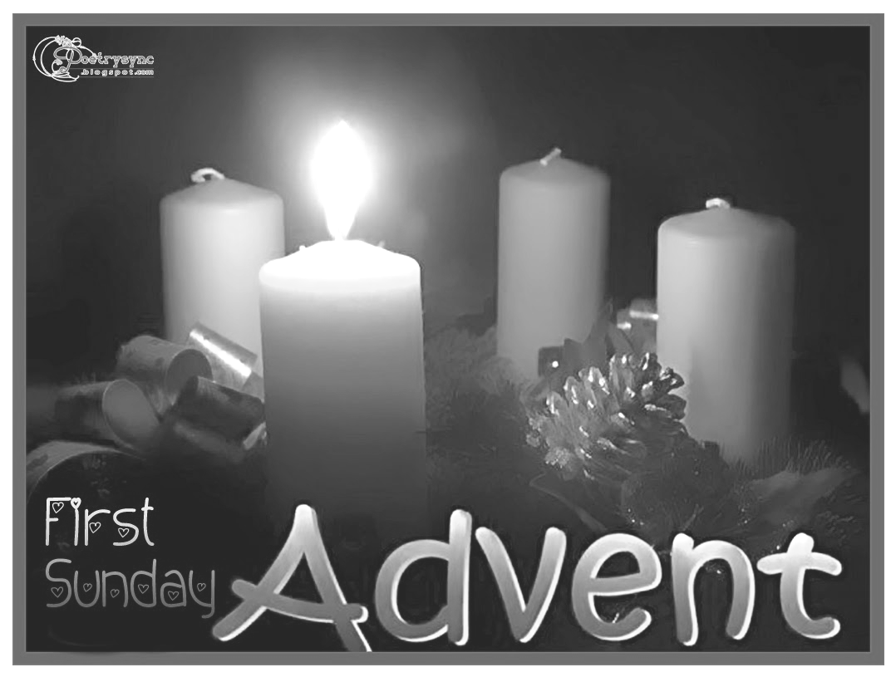
1st Sunday of Advent.
Year A.
27th November, 2016.

First Reading Is 2:1-5 A reading from the prophet Isaiah. The Lord will gather all nations in eternal peace in the kingdom of God. The vision of Isaiah son of Amoz, concerning Judah and Jerusalem. In the days to come the mountain of the Temple of the Lord shall tower above the mountains and be lifted higher than the hills. All the nations will stream to it, peoples without number will come to it; and they will say: ‘Come, let us go up to the mountain of the Lord, to the Temple of the God of Jacob that he may teach us his ways so that we may walk in his paths; since the Law will go out from Zion, and the oracle of the Lord from Jerusalem.’ He will wield authority over the nations and adjudicate between many peoples; these will hammer their swords into ploughshares, their spears into sickles. Nation will not lift sword against nation, there will be no more training for war. O House of Jacob, come, let us walk in the light of the Lord. The word of the Lord.

Responsorial Psalm Ps 121:1-2. 4-5. 6-9. R.
(R.) Let us go rejoicing to the house of the Lord. 1. I rejoiced when I heard them say: ‘Let us go to God’s house.’ And now our feet are standing within your gates, O Jerusalem. (R.)
2. It is there that the tribes go up, the tribes of the Lord. For Israel’s law it is, there to praise the Lord’s name. There were set the thrones of judgement of the house of David. (R.)
3. For the peace of Jerusalem pray: ‘Peace be to your homes! May peace reign in your walls, in your palaces, peace!’ (R.)
4. For love of my brethren and friends I say: ‘Peace upon you!’ For love of the house of the Lord I will ask for your good. (R.)

Second Reading Rom 13:11-14 A reading from the letter of St Paul to the Romans. The time has come, our salvation is near. You know ‘the time’ has come: you must wake up now: our salvation is even nearer than it was when we were converted. The night is almost over, it will be daylight soon – let us give up all the things we prefer to do under the cover of the dark; let us arm ourselves and appear in the light. Let us live decently as people do in the daytime: no drunken orgies, no promiscuity or licentiousness, and no wrangling or jealousy. Let your armour be the Lord Jesus Christ. The word of the Lord.

Gospel Acclamation Ps 84:8 Alleluia, alleluia! Lord, show us your mercy and love, and grant us your salvation. Alleluia!

Gospel Mt 24:37-44 A reading from the holy Gospel according to Matthew. Stay awake, you must be ready. Jesus said to his disciples: ‘As it was in Noah’s day, so will it be when the Son of Man comes. For in those days before the Flood people were eating, drinking, taking wives, taking husbands, right up to the day Noah went into the ark, and they suspected nothing till the Flood came and swept all away. It will be like this when the Son of Man comes. Then of two men in the fields one is taken, one left; of two women at the millstone grinding, one is taken, one left. ‘So stay awake, because you do not know the day when your master is coming. You may be quite sure of this that if the householder had known at what time of the night the burglar would come, he would have stayed awake and would not have allowed anyone to break through the wall of his house. Therefore, you too must stand ready because the Son of Man is coming at an hour you do not expect.’ The Gospel of the Lord.

RECENT DEATHS:

ANNIVERSARIES:
Margaret Final, Mannix Russell, Jake Inglis, Agnes Olney, Sr Mary Ryan, Vera Brown.

SICK: Lorraine Russell, Loretta Kervin,
Nathan DeLorenzo, Peter Stewart, Helen Hunt, Margaret Sinclair, Courtney McLennan,
Amber Bayne, Mitchell Johnstone,
Maddi Allardyce.

Wishing Father Peter a speedy
recovery from his recent surgery.

Annointing of the sick will take place after Mass on Sunday 11th December after Mass at both Churches.

WELCOME.
Parish of Cororooke.
P O Box 27, Cororooke 3254.
Phone: 5233 1282.

Moderator: Lucy Darcy 52331228.
Visiting Priest: Fr. Peter Murnane who has Sacramental responsibility including Baptisms, Weddings and Funerals 0478761231
School Principal: Anne Ruddell. 52331464.
St Brendan’s: 9.00am Sunday.
St Joseph’s: 10.30am Sunday.

ST BRENDAN’S: 4th Dec, 2016 9.00am.
Communion Minister: Louise Allan
Commentator: Chloe Grist
Reader: A. McCarthy
Organist:
Procession Gifts
Lay Leaders: L. McGuane/A. Ruddell

ST. JOSEPH’S: 10:30 am
Communion Minister: P. Roache
Family: M. Mahoney
Lay Leaders M.Carmody/M.Finn.

ALTAR & SACRISTY DUTIES:
St Joseph’s:
Dec: D Melville
Jan; Slater

ST BRENDAN’S:
27th Nov- 4th Dec. C Grist/M Allan
11th /18th Dec J.O’Dowd / H.Holland

COUNTERS:
November 27^{th:} N. McKay
Money is to be counted every 2nd weekend.

Dates to Remember:
11th Dec: End of School Year Mass/ Graduation 9.00am at St. Brendan’s.
11th Dec. Community Celebration of Forgiveness at 7.00pm at St. Brendan’s.
18th Dec: Christmas Carols in St. Brendan’s Church @ 7.00pm.

CHRISTMAS MASS TIMES;
24th Dec. 7.30pm St. Brendan’s
25th Dec. 10.30am St. Joseph’s.

Knight of the Southern Cross will be cleaning Church and Presbytery windows on the 11th December, 2016 at 10.30am. Thanks guys!
Overseas Aid: Wanted. Used stamps, with 1.5cm of envelope around stamp! Acrylic yarns for women’s craft groups in Peru. Please place in box at back of church.

Next year Trinity College will be celebrating 50yrs since establishment at the Pound Rd site. All former students and staff are invited to register on the Alumni Group. www.tcc.vic.edu.au/trinity/alumni
You can download the form or contact the school for further details. See letter at back of church.

ADVENT GIVING; Donations of non perishable items may be placed in baskets at back of churches. St. Vincent de Paul will make hampers.

New Parish Leadership Members 2017:
Parishioners are asked to start the discerning process. Flyers and recommendation forms are at back of each church. PLEASE give YOUR consideration for YOUR Parish Community.

World Youth Day Prayer Vigil of the Holy Father.
The Lord wants to turn your hands, my hands, our hands into signs of reconciliation, of communion, of creation to build a better world for all

- Baptism: Violet Lou daughter of Kate and Craig Cooper, 27th Nov.

- Liturgy Preparation for January- Jill/Caroline.


PRAYER FOR THE LIGHTING OF THE ADVENT CANDLE!
All: Loving God, you call us all to be your people united in faith. We thank you for this wreath the evergreen sign of your faithful love. We light this candle in hope, the hope of our coming Saviour, Jesus. Dispel the darkness of sin, that the light and joy of Jesus may shine in this waiting world. Let us prepare, then, the way of the Lord. We ask this through Christ our Lord, Amen.

