WELCOME
Parish of Cororooke.
P O Box 27, Cororooke 3254.
Email: cororooke@ballarat.catholic.org.au
Parish Sec: Trish Hickey 52314667/0428031340

Moderator: Maureen Finn, 52331458. 0428329231.
School Principal: Anne Ruddell. 52331464.
Child Safety Officer: Anne Ruddell
St Brendan’s: 9.30am Sunday.
St Joseph’s: 10.30am Sunday.

ST. BRENDAN’S: 9th Dec, 2018
Commentator: K. McKay
Reader: J. Miller
Musician: Liz McGuane
Communion: Maureen Finn.
Lay Leader:
Procession of Gifts: Tristan D’Altera

ST. JOSEPH’S: 9th Dec 2018
Family Smith
Communion L. Darcy
Lay Leaders:
ALTAR & SACRISTY DUTIES: St. Joseph’s.
Dec: D. Melville
Jan: Slater
St.Brendan’s;
2nd/9th Dec: M.Finn/M.Carmody.
15th/23rd Dec: C Grist/M Allan

COUNTERS;
2nd Dec: J. Miller.
16 Dec: P O’Shea.

RECENT DEATHS:
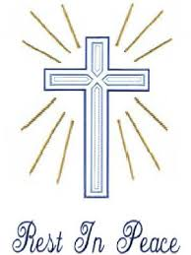
ANNIVERSARIES FOR December. (to be read out by Commentator). Lorraine Russell, Nell Matthews, Frank Finningan, Jan Finlay, Agnes Quirk, Christopher Fay, Mary Cole, Kate Mahoney, Fred Newcombe, Christopher Roache, Eric Monaghan, Margaret Hickey, Molly Mahoney, Connor Remmerswaal, Ann Paatsch, Edith Monaghan, Patty Sushames, Stewart Jackson, Jim Martin, Karen Finn, Laurel Devine.

SICK: Loretta Kervin, Nathan De Lorenzo, Peter Stewart, Helen Hunt, Maddi Allardyce, Helen Wilsher, Leah Spokes, Mitchell Johnstone, Ross Suares, Patricia Hickman.

Catholic Religious across Australia – National Day of Sorrow and Promise
In a collective response from Catholic religious orders across the country, religious women and men will hold a National Day of Sorrow and Promise on Sunday, December 2, 2018 - the beginning of Advent and the start of a new Church year. The day has emerged to acknowledge survivors of abuse within the Catholic Church and all those who have been hurt by that abuse. More information attached.

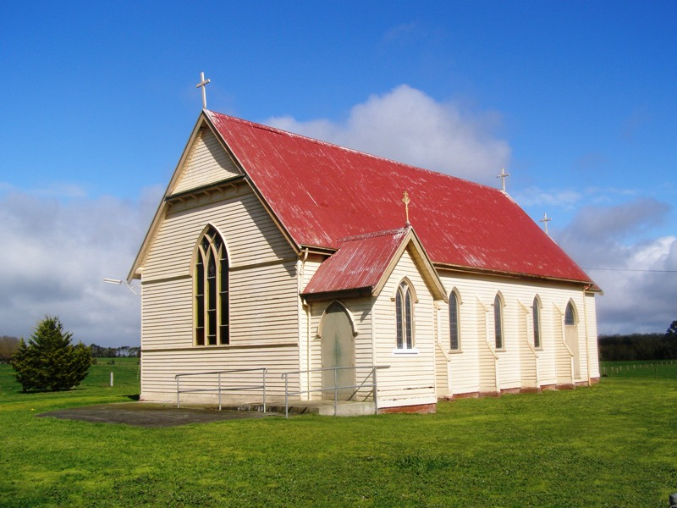
- NB; Mass at St Joseph’s, Pirron Yallock will be at 11am for Sunday 9th December. This week only.

- End of year School Mass on Sunday 9th December at 9.30am. Everyone is invited to the Hall for a cuppa afterwards.

MISSION DAY;
Further thanks to L & K Bakery for the magnificent Apple Pie they supplied which sold for $32.00.

CHRISTMAS MASS TIMES;
Christmas Mass will be celebrated @ St Brendan’s by Fr Tom Brophy @ 7pm on Christmas Eve.

BAPTISM;
Millie May Whytcross will be Baptised on December 9th @ St Joseph’s @ 11am. Millie is the child of Anthony and Tracey Whytcross. We wish them special blessings on this day.

Wedding:
Congratulations to Sheldon Convery-Oborne and Rhys Alexander on their marriage celebrated yesterday.

“Angel of God My guardian dear To
Whom His love Commits me here
Ever this day Be at my side
To light and guard To rule and guide”
Amen

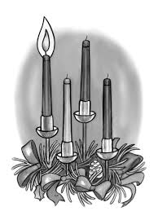
1st Sunday of Advent. Year C
2nd December, 2018.

First Reading Jer 33:14-16 I will cause a good seed to spring forth from David. See, the days are coming – it is the Lord who speaks – when I am going to fulfil the promise I made to the House of Israel and the House of Judah: ‘In those days and at that time, I will make a virtuous Branch grow for David, who shall practise honesty and integrity in the land. In those days Judah shall be saved and Israel shall dwell in confidence. And this is the name the city will be called: The Lord-our-integrity.’ Responsorial Psalm Ps 24:4-5. 8-9. 10. 14. R. v.1 (R.) To you, O Lord, I lift my soul.

1. Lord, make me know your ways. Lord, teach me your paths. Make me walk in your truth, and teach me: for you are God my saviour. (R.)

2. The Lord is good and upright. He shows the path to those who stray, he guides the humble in the right path; he teaches his way to the poor. ®

3. His ways are faithfulness and love for those who keep his covenant and will. The Lord’s friendship is for those who revere him; to them he reveals his covenant. (R.)

Second Reading 1 Thes 3:12–4:2 When Christ comes may he strengthen your hearts in holiness. May the Lord be generous in increasing your love and make you love one another and the whole human race as much as we love you. And may he so confirm your hearts in holiness that you may be blameless in the sight of our God and Father when our Lord Jesus Christ comes with all his saints. Finally, brothers, we urge you and appeal to you in the Lord Jesus to make more and more progress in the kind of life that you are meant to live: the life that God wants, as you learnt from us, and as you are already living it. You have not forgotten the instructions we gave you on the authority of the Lord Jesus.

Gospel Acclamation Ps 84:8 Alleluia, alleluia! Lord, show us your mercy and love, and grant us your salvation. Alleluia!

Gospel Lk 21:25-28, 34-36 Your redemption is near at hand. Jesus said to his disciples: ‘There will be signs in the sun and moon and stars; on earth nations in agony, bewildered by the clamour of the ocean and its waves; men dying

of fear as they await what menaces the world, for the powers of heaven will be shaken. And then

they will see the Son of Man coming in a cloud with power and great glory. When these things

begin to take place, stand erect, hold your heads high, because your liberation is near at hand. ‘Watch yourselves, or your hearts will be coarsened with debauchery and drunkenness and the cares of life, and that day will be sprung on you suddenly, like a trap. For it will come down on every living man on the face of the earth. Stay awake, praying at all times for the strength to survive all that is going to happen, and to stand with confidence before the Son of Man.’

DATES TO REMEMBER:

- 2nd December, Community Celebration of Forgiveness.
- 23rd December, Annointing Mass.

CHRISTMAS CRIBS “MAKING A SCENE AT CHRISTMAS” At St MARY’S. Gathering Space COLAC Thursday November 29 – Sunday December 2 Time: 9:am – 6:pm MAKING A SCENE AT CHRISTMAS is a display of over 400 Christmas Nativities from more than 50 countries. You can - see and smell real frankincense and myrrh; - see a coin minted at the time the census was called that brought Joseph and Mary to Bethlehem; and - see cultural nativities from Australia, Africa, Asia, North & South America, & Europe - Nativities that prize social justice and the environment Entry is a gold coin donation. Everyone welcome. Last chance this weekend.

Advent liturgies @ 9:15 each Friday, will be held at the School.
The season of Advent is a period of both repentance and celebration. Christians spend time in spiritual preparation for the coming of Jesus Christ at Christmas. Believers remember not only Christ's first coming to earth as a human baby but also celebrate his continued presence with us today through the Holy Spirit. Advent is also a time for worshipers to anticipate his return at the Second Coming of Christ.

