2nd Sunday of Easter

Year C – 3rd April, 2016

First Reading Acts 5:12-16 A reading from the Acts of the Apostles .The numbers of men and women who came to believe in the Lord increased steadily. The faithful all used to meet by common consent in the Portico of Solomon. No one else ever dared to join them, but the people were loud in their praise and the numbers of men and women who came to believe in the Lord increased steadily. So many signs and wonders were worked among the people at the hands of the apostles that the sick were even taken out into the streets and laid on beds and sleepingmats in the hope that at least the shadow of Peter might fall across some of them as he went past. People even came crowding in from the towns round about Jerusalem, bringing with them their sick and those tormented by unclean spirits, and all of them were cured. The word of the Lord.

Responsorial Psalm Ps 117:2-4. 22-27. R. v.1 (R.) Give thanks to the Lord for he is good, his love is everlasting..
1. Let the sons of Israel say: ‘His love has no end.’ Let the sons of Aaron say: ‘His love has no end.’ Let those who fear the Lord say: ‘His love has no end.’ (R.)
2. The stone which the builders rejected has become the corner stone. This is the work of the Lord, a marvel in our eyes. This day was made by the Lord; we rejoice and are glad. (R.)
3. O Lord, grant us salvation; O Lord grant success. Blessed in the name of the Lord is he who comes. We bless you from the house of the Lord; the true God is our light. (R.)

Second Reading Rv 1:9-13, 17-19 A reading from the book of the Apocalypse I was dead and now I am to live for ever and ever. My name is John, and through our union in Jesus I am your brother and share your sufferings, your kingdom, and all you endure. I was on the island of Patmos for having preached God’s word and witnessed for Jesus; it was the Lord’s day and the Spirit possessed me, and I heard a voice behind me, shouting like a trumpet, ‘Write down all that you see in a book.’ I turned round to see who had spoken to me, and when I turned I saw seven golden lamp-stands and, surrounded by them, a figure like a Son of man, dressed in a long robe tied at the waist with a golden girdle. When I saw him, I fell in a dead faint at his feet, but he touched me with his right hand and said, ‘Do not be afraid; it is I, the First and the Last; I am the Living One. I was dead and now I am to live for ever and ever, and I hold the keys of death and of the underworld. Now write down all that you see of present happenings and things that are still to come.’ The word of the Lord.

Gospel Acclamation Jn 20:29 Alleluia, alleluia! You believe in me, Thomas, because you have seen me; happy those who have not seen me, but still believe! Alleluia!

Gospel Jn 20:19-31 A reading from the holy Gospel according to John. After eight days Jesus came in and stood among them. In the evening of that same day, the first day of the week, the doors were closed in the room where the disciples were, for fear of the Jews. Jesus came and stood among them. He said to them, ‘Peace be with you,’ and showed them his hands and his side. The disciples were filled with joy when they saw the Lord, and he said to them again, ‘Peace be with you. ‘As the Father sent me, so am I sending you.’ After saying this he breathed on them and said: ‘Receive the Holy Spirit. For those whose sins you forgive, they are forgiven; for those whose sins you retain, they are retained.’ Thomas, called the Twin, who was one of the Twelve, was not with them when Jesus came. When the disciples said, ‘We have seen the Lord’, he answered, ‘Unless I see the holes that the nails made in his hands and can put my finger into the holes they made, and unless I can put my hand into his side, I refuse to believe.’ Eight days later the disciples were in the house again and Thomas was with them. The doors were closed, but Jesus came in and stood among them. ‘Peace be with you’ he said. Then he spoke to Thomas, ‘Put your finger here; look, here are my hands. Give me your hand; put it into my side. Doubt no longer but believe.’ Thomas replied, ‘My Lord and my God!’ Jesus said to him: ‘You believe because you can see me. Happy are those who have not seen and yet believe.’ There were many other signs that Jesus worked and the disciples saw, but they are not recorded in this book. These are recorded so that you may believe that Jesus is the Christ, the Son of God, and that believing this you may have life through his name. The Gospel of the Lord

RECENT DEATHS:

ANNIVERSARIES : Daniel Roache, Frank Page, Pat Harney, Danny Moore, Mary Garner, Carol Miller, Brian Ritchie.

SICK: Lorraine Russell, Loretta Kervin, Nathan DeLorenzo, Peter Stewart,
Helen Hunt, Margaret Sinclair.

WELCOME
Parish of Cororooke.
P.O. address: P O Box 27, Cororooke 3254.
Phone: 5233 1282
Email: cororooke@ballarat.catholic.org.au.

ST BRENDAN’S: Sunday 10th April , 2016
Communion Minister:
Commentator:
Reader:
Organist:
Procession Gifts:
Lay Leaders:

ST. JOSEPH’S:
Communion Minister:
Family:
Lay Leaders

ALTAR & SACRISTY DUTIES:
St Joseph’s:
April. J.& M. Melville
May A.Convery/A Oborne
St Brendan’s:
3rd/10th: M. O’Shea/K. Smith
17th/24th: L. McGuane/A.Ruddell.

COUNTERS:
3/4 L. Darcy
10/4 L. Russell.

Liturgy Preparation Roster:
May: Marita & Carmel.

THANK YOU;

- To all our Liturgy Planners and Parishioners for your involvement in the Easter Season. Your contribution to the life of our Parish is appreciated.
To the Lenehan family who donated the flowers in memory of Francis who for so many years supplied flowers for Christmas and Easter, we will never forget Francis and those who have gone before us who gave so much of their time and care to our Parish. Our challenge is to continue “the story they wrote”

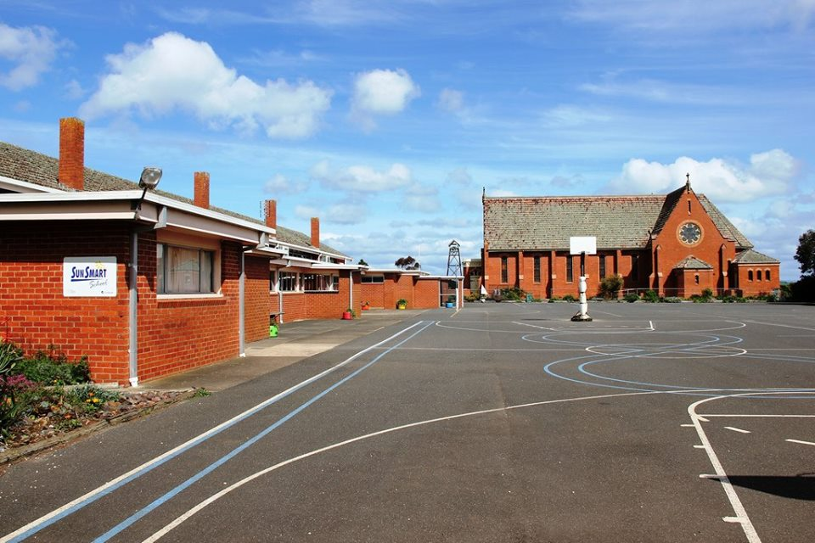

St Brendan’s Heritage Day
Sunday, 10th April, 2016.

MASS will not be held @St JOSEPH’S on this day.

Entry $ 15 per person {included Devonshire Tea } or entry& lunch $30 per person BBQ (Pre Paid)
Book on line or get your tickets from Café Rooke.

There will be a sausage sizzle for $2
Please note Children under 15 have free entry
6 buildings to explore and entertainment provided,

MAKE A DAY OF IT…HAVE FUN.

Please return your Project Compassion box/envelope if you have not already done so.


As Ann McCarthy & Liz McGuane and others set of today on a 200km walk in the footsteps of Mary McKillop, taking them from Portland to Penola, via the coastline we wish them well and hope they have packed liniment and Voltaren!!!!

