4th Sunday of Easter
Year C – 17th April, 2016

First Reading Acts 13:14, 43-52 A reading from the Acts of the Apostles. We are now turning to the gentiles. Paul and Barnabas carried on from Perga till they reached Antioch in Pisidia. Here they went to synagogue on the sabbath and took their seats. When the meeting broke up, many Jews and devout converts joined Paul and Barnabas, and in their talks with them Paul and Barnabas urged them to remain faithful to the grace God had given them. The next sabbath almost the whole town assembled to hear the word of God. When they saw the crowds, the Jews, prompted by jealousy, used blasphemies and contradicted everything Paul said. Then Paul and Barnabas spoke out boldly, ‘We had to proclaim the word of God to you first, but since you have rejected it, since you do not think yourselves worthy of eternal life, we must turn to the pagans. For this is what the Lord commanded us to do when he said: I have made you a light for the nations, so that my salvation may reach the ends of the earth.’ It made the pagans very happy to hear this and they thanked the Lord for his message; all who were destined for eternal life became believers. Thus the word of the Lord spread through the whole countryside. But the Jews worked upon some of the devout women of the upper classes and the leading men of the city and persuaded them to turn against Paul and Barnabas and expel them from their territory. So they shook the dust from their feet in defiance and went off to Iconium; but the disciples were filled with joy and the Holy Spirit. The word of the Lord.

Responsorial Psalm Ps 99:1-3. 5. R. v.3
(R.) We are his people, the sheep of his flock.
1. Cry out with joy to the Lord, all the earth. Serve the Lord with gladness. Come before him, singing for joy. (R.)
2. Know that he, the Lord, is God. He made us, we belong to him, we are his people, the sheep of his flock. (R.)
3. Indeed, how good is the Lord, eternal his merciful love. He is faithful from age to age. (R.)

Second Reading Rv 7:9, 14-17
A reading from the book of the Apocalypse. The Lamb who is at the throne will be their shepherd and will lead them to springs of living water. I, John, saw a huge number, impossible to
count, of people from every nation, race, tribe and language; they were standing in front of the
throne and in front of the Lamb, dressed in white robes and holding palms in their hands. One of the elders said to me, ‘These are the people who have been through the great persecution, and because they have washed their robes white again in the blood of the Lamb, they now stand in front of God’s throne and serve him day and night in his sanctuary; and the One who sits on the throne will spread his tent over them. They will never hunger or thirst again; neither the sun nor scorching wind will ever plague them, because the Lamb who is at the throne will be their shepherd and will lead them to springs of living water; and God will wipe away all tears from their eyes.’ The word of the Lord.

Gospel Acclamation Jn 10:14 Alleluia, alleluia! I am the good shepherd, says the Lord; I know my sheep, and mine know me. Alleluia!

Gospel Jn 10:27-30 A reading from the holy Gospel according to John. I give my sheep eternal life. Jesus said: ‘The sheep that belong to me listen to my voice; I know them and they follow me. I give them eternal life; they will never be lost and no one will ever steal them from me. The Father who gave them to me is greater than anyone, and no one can steal from the Father. The Father and I are one.’ The Gospel of the Lord

RECENT DEATHS:

ANNIVERSARIES :
Duane Roache, David Lenehan, Ann Williams, Kevin Oborne, Sr T. Hyland, Brendan Baggott, Molly Morrissey, Tom Page, Jack Harney, Sr L. Carmody.

SICK: Lorraine Russell, Loretta Kervin, Nathan DeLorenzo, Peter Stewart,
Helen Hunt, Margaret Sinclair.


WELCOME
Parish of Cororooke.
P O Box 27,Cororooke 3254.
Phone: 5233 1282

Sunday 24th April , 2016.
ST BRENDAN’S:
Communion Minister: M. Allan
Commentator: E. McGuane
Reader: M. Finn.
Organist: L. McGuane
Procession Gifts: Genevieve McGuane.
Lay Leaders:

ST. JOSEPH’S:
Communion Minister: A. Convery
Family: Hickman
Lay Leaders

ALTAR & SACRISTY DUTIES:
St Joseph’s:
April. J.& M. Melville
May A.Convery/A Oborne

St Brendan’s:
17th/24th: L. McGuane/A.Ruddell.
1st/8th May: A. McCarthy/D. Howard.

COUNTERS:
17/4 J.Miller
24/4 P. O’Shea.

Liturgy Preparation Roster:
May: Marita & Carmel.

Almighty ever-living God,
lead us to a share in the joys of heaven,
so that the humble flock may reach
where the brave Shepherd has gone before.
Who lives and reigns with you in the unity of the Holy Spirit, one God, for ever and ever.

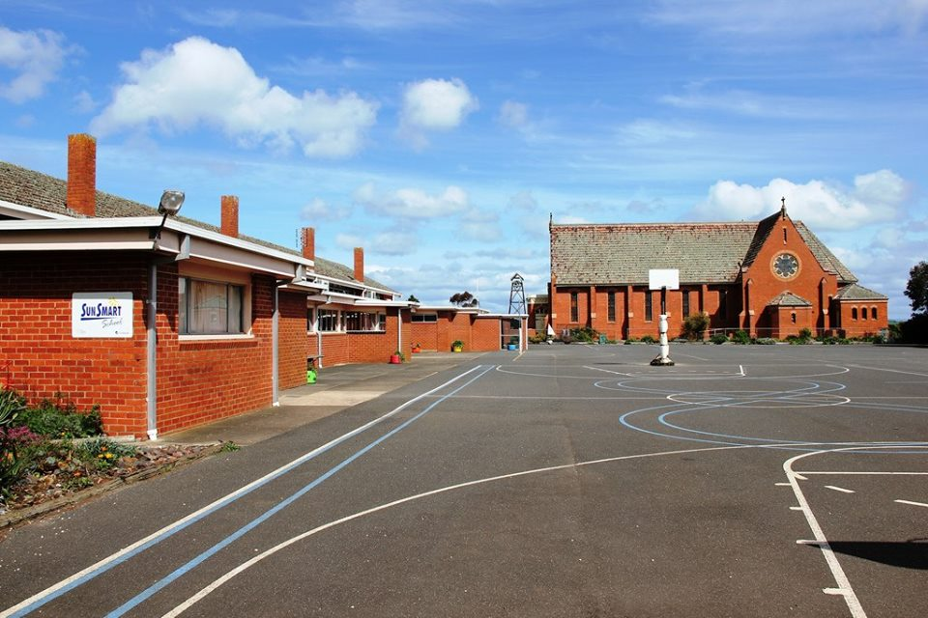

Our Parish was displayed in all its beautiful glory last weekend as we welcomed current and past parishioners, nuns, former students and visitors from near and far to celebrate Heritage Day.

Our P&F are to be congratulated and thanked for their organisation and tireless efforts on Sunday and in the period leading up to it, so well summed up by Gerrard Monaghan on Facebook.

“Gerrard Monaghan
9 April at 20:07
So proud to be part of an amazing school community. The huge amount of work done to have everything looking so pristine is fantastic Thank you to everyone. We are all so excited to be able to put together such a great event. I hope everyone has a brilliant day.”



