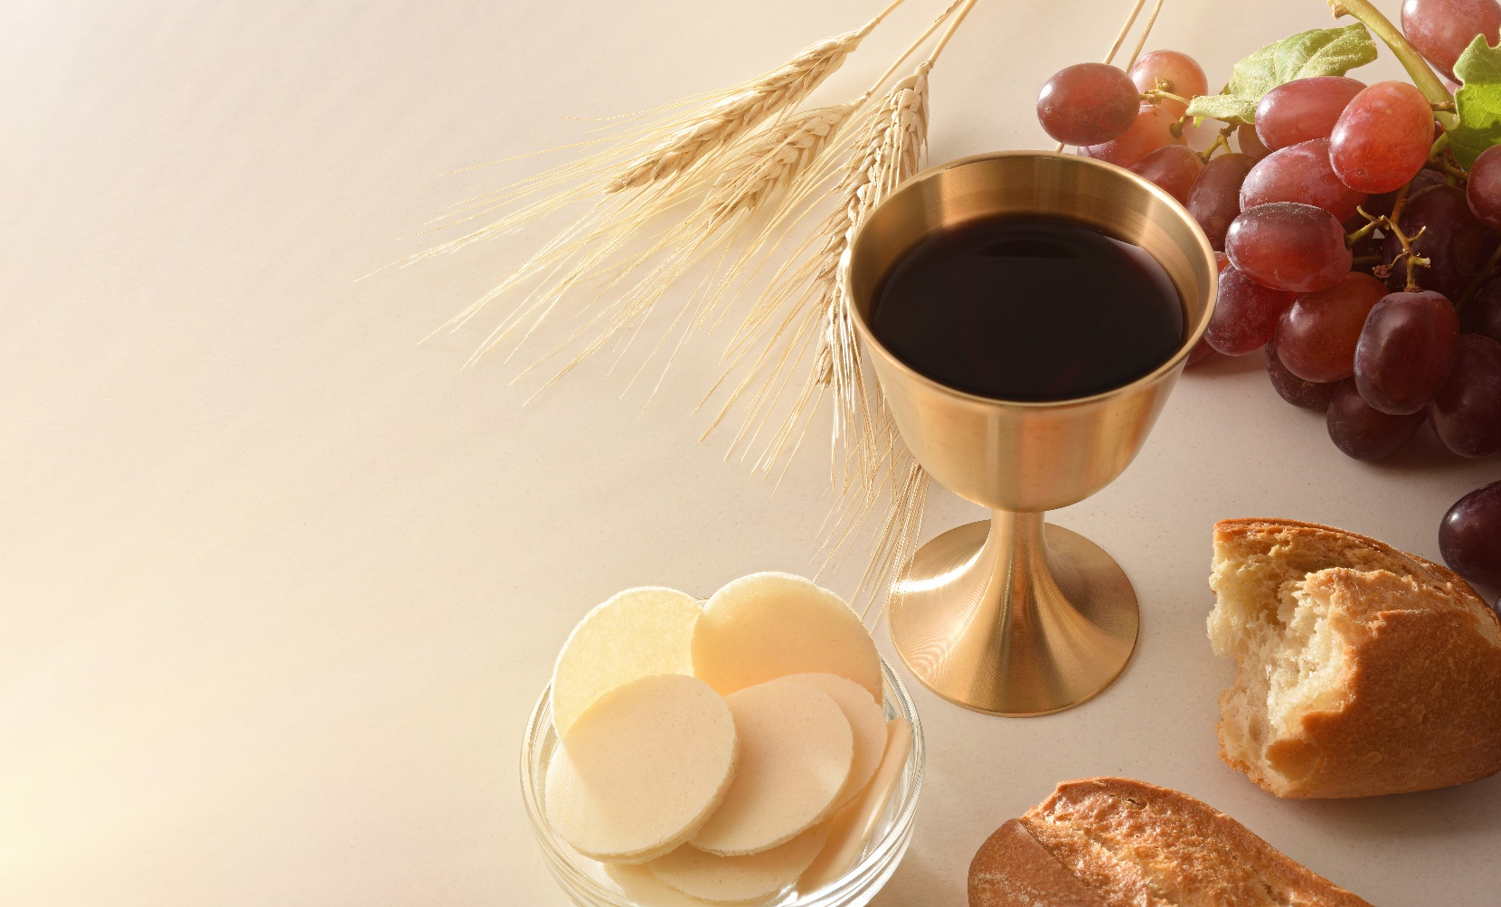

Reintroducing Communion from the Chalice:

Some Reflections

On September 28, I wrote to the people of the diocese about reintroducing the option of receiving communion from the chalice. This practice had been suspended in the early days of the Covid pandemic. However, with other Covid restrictions lifted, it seems appropriate to lift this restriction as well. Communion from the chalice may be reintroduced in the diocese of Ballarat from November 1, All Saints Day.

The reintroduction of communion from the chalice provides us with an opportunity to contemplate the significance of this practice as an important element in our celebration of the Eucharist. I would like to offer some reflections that I hope will help our communities appreciate the rich meaning of the communion with Christ that we celebrate in the Eucharist under the appearances of bread and wine.

# Taking bread and wine: Doing what Jesus did

What we do at the Eucharist is modelled on what Jesus did at the Last Supper. On the night before he died, as he shared a meal with his disciples, Jesus took bread, said a prayer of blessing, broke the bread and gave it to his disciples, saying, “Take this, all of you, and eat of it, for this is my body, which will be given up for you.” After supper he took a cup of wine, gave God thanks and praise, and gave the cup to his disciples, saying, “Take this, all of you, and drink from it, for this is the chalice of my blood, the blood of the new and eternal covenant, which will be poured out for you and for many for the forgiveness of sins.” Then Jesus said, “Do this in memory of me.” He directed us to do what he had done as his memorial, in thanksgiving for all the wonderful gifts of God.

Each of the main parts of our Liturgy of the Eucharist corresponds to one of these actions of Jesus. He took the bread and cup; in the Preparation of the Gifts, we take the bread and the cup of wine. He said a prayer of blessing over the bread and gave thanks and praise over the cup; we do this in the Eucharistic Prayer. Jesus then broke the bread and gave himself to his disciples under the form of bread and in the sharing of the cup; in the Communion Rite we receive Christ under the form of the bread broken and the cup shared.

When we share the cup as well as receiving the host, we are taking part more fully in the actions of Jesus at the Last Supper. We are following more closely the pattern he gave us as his memorial.

# Bread and wine as signs of life and joy

As we meditate on the Eucharist, it is useful to reflect on the elements that Jesus chose as the basis for this sacrament, the elements of bread and wine. These play an important part in our ordinary lives, and they are given an even richer meaning in the Eucharist.

We are familiar with bread as a staple of life. We even use the word “bread” to stand for all food, as when we say that people earn their bread by the sweat of their brow. We need food to sustain our life. From this point of view, bread is a sign that we depend on something beyond ourselves for our very existence. The bread that we eat, the food that we receive, gives us life. So, in the Eucharist, the bread that has become the Body of Christ is our food for eternal life.

If we think of bread as a staple food for ordinary life, we might associate wine more with special occasions. Wine can add a festive note to a celebration. So, in the Eucharist, the wine that has become the Blood of Christ can speak of the eternal banquet that God has prepared for us.

Bread and wine also speak of union. The ordinary bread that we eat and the wine that we drink become one with us. Furthermore, our sharing of bread and wine in a meal with others is a sign of friendship and union with those who are with us at the table. So, in the Eucharist, in receiving Christ in the form of bread and wine we are united with him. We are also united with those who share the Eucharist with us. We are one in Christ because we share the one heavenly bread and the one heavenly cup.

# Bread and wine in the Scriptures

In choosing bread and wine as the basic elements of the Eucharist, Jesus drew on the meaning that bread and wine have in our daily lives. He also drew on the meaning of bread and wine in the Scriptures.

In the first book of the Bible, the book of Genesis, Melchizedek offers bread and wine as he blesses Abram. “King Melchizedek of Salem brought out bread and wine; he was priest of God Most High. He blessed him and said, ‘Blessed be Abram by God Most High, maker of heaven and earth.’” (Genesis 14:18) Bread and wine are linked with the blessing of God.

A little later in the story, Abraham offers bread to three travellers who come his way. “Let me bring a little bread that you may refresh yourselves” (Genesis 18:5) Bread is a sign of hospitality and a source of refreshment.

The book of Exodus describes the festival of unleavened bread as a memorial of the people being freed from slavery in Egypt. “You shall observe the festival of unleavened bread, for on this very day I brought your companies out of the land of Egypt.” (Exodus 12:17) The people are to eat bread in thanksgiving for their freedom.

As the people wander in the desert, their supplies of food run out, but God feeds them with manna from heaven. “The Lord said to Moses, ‘I am going to rain bread from heaven for you.’” (Exodus 16:4) Bread from heaven is a sign of God’s providence, God’s care for the people at each stage of their journey.

As bread and wine are linked with daily life, so the Scriptures link them with both joy and sorrow. Deuteronomy 16:3 speaks of unleavened bread as “the bread of affliction”, a memorial of the people’s suffering as slaves in Egypt. Psalm 80:5 refers to “the bread of tears”. The prophet Jeremiah speaks of “the wine of wrath”. “Take from my hand this cup of the wine of wrath.” (Jeremiah 25:15) By contrast, Psalm 104 links bread and wine with strength and gladness. “You bring forth food from the earth, and wine to gladden the human

heart, oil to make the face shine, and bread for strength.” (Psalm 104:14-15) As we take bread and wine for the Eucharist, they can symbolise the joys and sorrows of our lives, ready to be taken up into the prayer of Christ.

In the gospels, Jesus teaches his disciples to pray for the bread they need each day. “Give us this day our daily bread.” (Matthew 6:11). Each time we celebrate the Eucharist, we say these words before communion as part of the Lord’s Prayer. We pray for the ordinary bread that we need for our daily lives and for the heavenly bread of the Eucharist that is the food of eternal life.

The gospels tell of Jesus feeding thousands of people from a few loaves of bread. As he does so, Jesus recalls the manna, the bread from heaven, that God gave the people in the desert and Jesus says that he will give an even greater heavenly bread, the bread that is himself. “Jesus said to them, ‘I am the bread of life. Whoever comes to me will never be hungry, and whoever believes in me will never thirst.’” (John 6:35) Jesus invites us to come to him in the Eucharist. There he offers us himself as the living bread that satisfies the hungry and the heavenly wine that satisfies the thirsty.

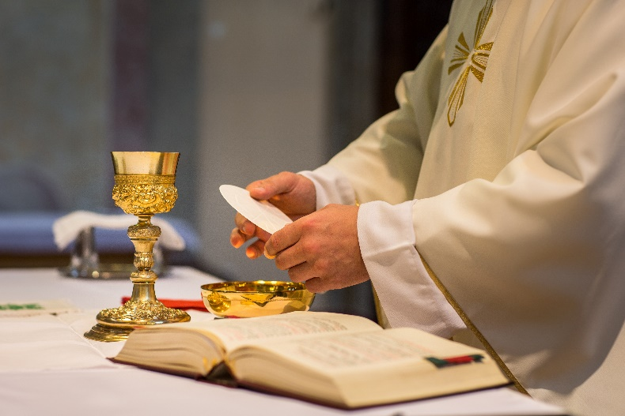St Paul explains the sharing of the eucharistic bread as a sharing in the body of Christ and the sharing of the cup of blessing as a sharing in Christ’s blood. “The cup of blessing that we bless, is it not a sharing in the blood of Christ? The bread that we break, is it not a sharing in the body of Christ?” (1 Corinthians 10:16)

Reflecting on such texts of the Scriptures can enrich our appreciation of the Eucharist, in which bread and wine become for us the body and blood of Christ. This is beautifully expressed in the prayers we say at Mass, as the bread and wine are placed on the altar.

As we take the bread we pray, “Blessed are you, Lord God of all creation, for through your goodness we have received the bread we offer you: fruit of the earth and work of human hands, it will become for us the bread of life.”

As we take the wine we pray, “Blessed are you, Lord God of all creation, for through your goodness we have received the wine we offer you: fruit of the vine and work of human hands, it will become our spiritual drink.”

# Notes on Communion in the Introduction to the Missal

The Missal that provides us with the prayers for Mass also provides us with notes on the various elements of the celebration. These include some observations about receiving Christ in communion under the appearances of bread and wine.

The Missal notes that the Communion Rite begins with the Lord’s Prayer, in which we pray for our daily bread, and links this particularly with the gift of the Eucharistic Bread. Those gathered then exchange a sign of peace, praying for peace and unity before sharing in the sacrament of unity. There follows the breaking of the Eucharistic Bread, signifying that “the many faithful are made one body (1 Corinthians 10:17) by receiving Communion from the one Bread of Life, which is Christ”. (General Instruction of the Roman Missal, paragraph 83)

As an immediate preparation for receiving communion, the Missal mentions personal prayer on the part of the priest and the members of the congregation. “The Priest prepares himself by a prayer, said quietly, so that he may fruitfully receive the Body and Blood of Christ. The faithful do the same, praying silently.” The priest then holds up the Eucharistic Bread (and may also hold up the chalice) and invites the people to share in Christ’s banquet. “Then the Priest shows the faithful the Eucharistic Bread, holding it over the paten or over the chalice, and invites them to the banquet of Christ.” (paragraph 84)

The Missal then highlights the value of receiving communion from hosts consecrated at the Mass being celebrated and receiving communion from the chalice. “It is most desirable that the faithful, just as the Priest himself is bound to do, receive the Lord’s Body from hosts consecrated at the same Mass and that, in the cases where this is foreseen, they partake of the chalice, so that even by mean of the signs Communion may stand out more clearly as a participation in the sacrifice actually being celebrated.” (paragraph 85)

In a later section of the notes, the Missal refers again to the value of communion “under both kinds”, that is, under the appearances of bread and wine. “Holy Communion has a fuller form as a sign when it takes place under both kinds. For in this form the sign of the Eucharistic banquet is more clearly evident and clearer expression is given to the divine will by which the new and eternal Covenant is ratified in the Blood of the Lord, as also the connection between the Eucharistic banquet and the eschatological banquet in the Kingdom of the Father.” (paragraph 281)

The Missal recalls the teaching of the Council of Trent about receiving communion under only one kind, that is, under the appearance of bread or wine. Pastors “should instruct the Christian faithful that the Catholic faith teaches that Christ, whole and entire, and the true Sacrament, is received even under only one species, and hence that as regards the resulting fruits, those who receive under only one species are not deprived of any grace that is necessary for salvation.” Nevertheless, the Missal then reaffirms the value of receiving communion under both kinds. “At the same time, the faithful should be instructed to participate more readily in this sacred rite, by which the sign of the Eucharistic banquet is made more fully evident.” (paragraph 282)

The Missal outlines the usual procedure for communion from the chalice. “If Communion of the Blood of Christ is carried out by communicants’ drinking from the chalice, each communicant, after receiving the Body of Christ, moves to the minister of the chalice and stands facing the minister. The minister says, “The Blood of Christ,” the communicant replies, “Amen”, and the minister hands over the chalice, which the communicant raises to his or her mouth. Each communicant drinks a little from the chalice, hands it back to the minister, and then withdraws; the minister wipes the rim of the chalice with the purificator.” (paragraph 286)

# Conclusion

In the diocese of Ballarat, communities may reintroduce the option of communion from the chalice from November 1 this year. This provides us with an occasion to reflect anew on the meaning of the Eucharist that we celebrate. I hope the notes I have offered here will be helpful in this reflection.

From All Saints Day, local communities will be free to offer communion from the chalice to any of the faithful who wish to take this option. I leave it to the judgment of the Parish Priest or Administrator in each place to arrange when and how communion is offered from the chalice. The practices may vary from place to place. However, the common aim is to provide opportunities for the faithful to receive Christ under the appearance of wine as well as under the appearance of bread, following the words of Jesus “Take and eat” and “Take and drink”. In this way, communion is more clearly a sign of sharing in Christ’s heavenly banquet.

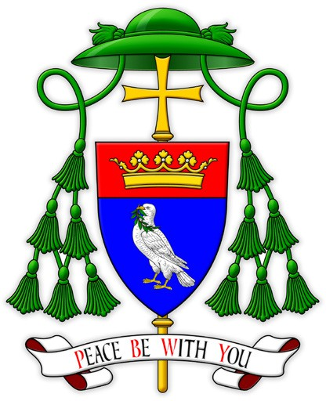From All Saints Day, communicants in our diocese will again have the option of communion from the chalice. May the revival of this practice enrich our celebration of our communion with Christ and with one another.

Paul Bird CSsR

Bishop of Ballarat